school microclimate

Elementary school and Kindergarten, Šanov, Znojmo district, contribution organisation
Komenského 241, 681 68 Šanov

Content
Project description 3
Project intent 3
Project goal 3
Pupils' competence 3
Target group 4
Material equipment 4
1st part of the project – Installation of a meteorological station with sensors 5
2nd part of the project – Programming in the MakeCode environment 8
Phase 1 – Introduction to the MakeCode programming environment 8
2nd phase – Connection of external modules 9
1. st project block 10
2. nd project block 10
3.rd project block 10
4th project block 11
5.th project block 11
3. Phase - Data Collection 13
3.rd part of the project - Designing the arrangement of garden elements in the school garden 14
4.th part of the project – Use of external modules in the investigation of physical quantities 17
Attachment 18
Attachment n. 1 18
Attachment n. 2 20

Project description

Project intent
There is a fenced plot of land in the school grounds, which was not used by the school in the past. It was therefore possible to use this part of the school grounds as a school garden, which would serve not only for educational purposes in subject Work education across grades, but also as a space where classes could take place in other subjects, by building an outdoor classroom.
The project is therefore focused on the layout of the individual planned elements of the school garden (space for raised beds, for fields with root crops, edible bushes, herb beds, etc.) in such a way as to make the best use of the potential of the space, by collecting and analysing information on temperature, soil moisture , rainfall and solar radiation intensity through a meteorological station.

Project goal
The goal is therefore to determine, based on the collected information and its analysis, the habitats where individual crops will thrive best. This information is necessary for the implementation of the school garden so that the crops and products can be used for the needs of the school and the school canteen.
At the same time, the project also has a communal impact; information from the weather station will be available to the general public via a link on the school's website.
Part of the project also includes the preparation of records for laboratory work in physics, in which individual external modules with sensors connected to a micro:bit programmable board are used for educational purposes to observe the dependence of selected physical quantities.

Pupils' competence
During the implementation of the project, students will improve their teamwork skill, communicative and presentation skills, strengthen their ability to use modern technologies through data processing and analysis, improve digital competence in relation to sustainability, the ability to use theoretical knowledge and obtain outputs in building school gardens.

Target group
The project is primarily intended for students from the 7th grade, subsequently it is possible to use the data obtained during the implementation of the project during laboratory work in physics by the students of individual classes from 5th to 9th grade.

Material equipment

name | for 1 pc (CZK) | number of pieces (pcs) | Total price | link
BBC MICRO:BIT KIT for Internet of Things IOT | 1 936 | 10 | 19 360 | https://www.hwkitchen.cz/bbc-microbit-kit-pro-internet-veci-iot/
MICRO:BIT KIT for health care (without MICRO:BIT) | 1 662 | 10 | 16 620 | https://www.hwkitchen.cz/microbit-kit-pro-peci-o-zdravi-smart-healt/
MICRO:BIT KIT for crafty farmers (without MICRO:BIT) | 1 591 | 5 | 7 955 | https://www.hwkitchen.cz/microbit-kit-pro-mazane-farmare-smart-agriculture/
BBC MICRO:BIT KIT for the smart home | 1 591 | 5 | 7 955 | https://www.hwkitchen.cz/bbc-microbit-kit-pro-chytrou-domacnost/
BBC MICRO:BIT V1.5 – a microcomputer for teaching programming | 560 | 30 | 16 800 | https://www.hwkitchen.cz/bbc-microbit-mikropocitac-pro-vyuku-programovani/
CUTEBOT - MICRO:BIT smart racing car V3.0 | 1 020 | 10 | 10 200 | https://www.hwkitchen.cz/cutebot-microbit-chytre-zavodni-auto/
Wi-Fi weather station GARNI 2055 Arcus | 8 690 | 1 | 8 690 | https://www.alza.cz/garni-2055-arcus-d6095336.html
Solar polycrystalline panel 5V/12V for powering the weather station | 1 600 | 1 | 1 600 | https://www.datart.cz/solarni-panel-viking-30w-vsp30w.html
TOTAL COST AMOUNT | 89 180 Kč

1st part of the project – Installation of a meteorological station with sensors

Time required: 4 teaching hours
Target group: 7th grade students
As part of the project, a GARNI 2055 Arcus weather station with an integrated 7-in-1 wireless sensor with a built-in fan was purchased, with which we will collect and record accurate and detailed weather information. The meteorological station records data on:
- internal temperature,
- relative humidity,
- wind speed and direction,
- rainfall,
- barometric pressure,
- UV index,
- intensity of solar radiation.
As part of the Vocational Education subject, the students installed a meteorological station in the fenced area of ​​the school garden and, according to the product instructions, calibrated the individual sensors under the teacher's supervision. Subsequently, data transfer from the meteorological station to the server of the Weathercloud web service was set up.
Data obtained from this weather station can be tracked not only by pupils and teachers, but also the general public, through a link to the Weathercloud web service server located on the school's website - see picture 1.
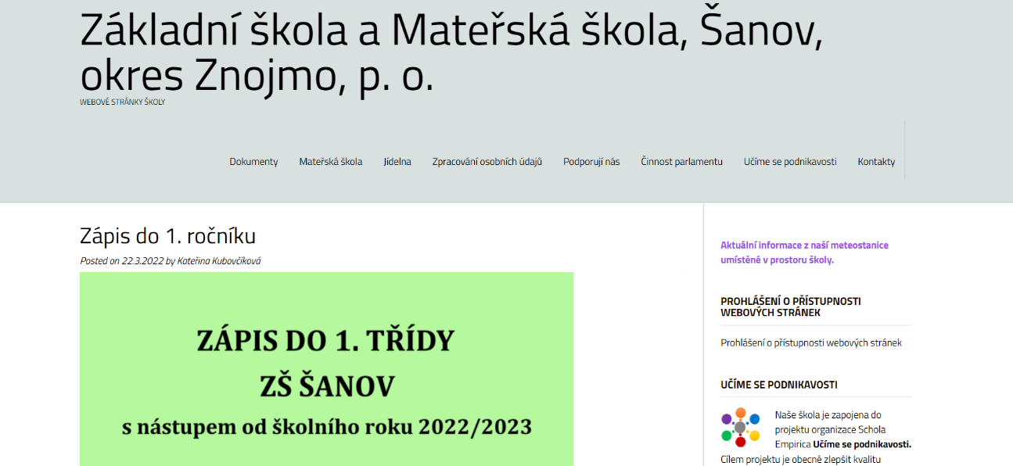
Obrázek - odkaz na server webové služby Weathercloud

Picture 1 – School website with a link to current information from the weather station
With this link, it is possible to follow not only current weather information, but also the development of individual monitored weather data over time - see picture 2 and 3.

Picture 3 – Weathercloud web service
Picture 2 – Weathercloud web service
The weather station also includes a colour inverse V.A. a display with dimensions of 163 x 120 mm, which was installed in the common indoor areas of the school, where current information about the weather is displayed. This proved to be very effective; every student and teacher has the opportunity to obtain information about the current temperature, wind strength, probability of precipitation, etc., and thus plan their teaching activities for indoor or outdoor spaces.
Recommendation: as part of the Work Education subject, students can design and implement a method of fixing a weather station in an outdoor environment. Here, however, it is necessary to observe the individual instructions for the installation of the meteorological station (location height, distance of individual sensors from surrounding objects, shady place for the correct functionality of the temperature and air humidity sensor, etc.).

2nd part of the project – Programming in the MakeCode environment

The second part of the project was focused on the development of students' teamwork skills and strengthening their abilities in the field of using modern technologies in the acquisition, processing and analysis of the obtained data.
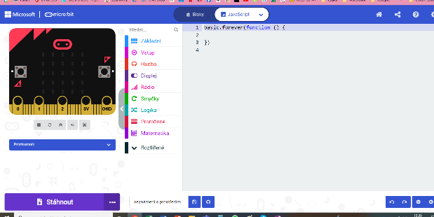
The goal was to familiarise the students with the MakeCode programming environment for the micro:bit minicomputer, and subsequently to program the selected sensors so that they record the necessary information during a predetermined time period, with which the students will continue to work.
Obrázek 4 – Programovací prostředí v blocích
Obrázek 5 – Programovací prostředí v JavaScriptu
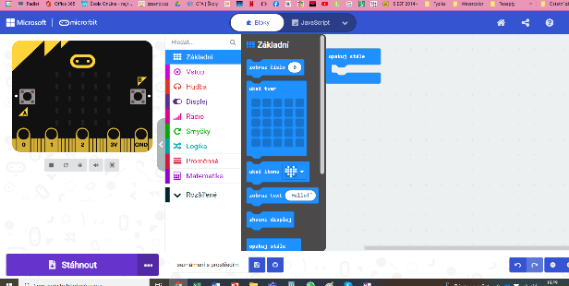

Phase 1 – Introduction to the MakeCode programming environment

Time required: 2 teaching hours
Target group: 7th grade students
MakeCode was chosen as the programming environment for working with the micro:bit, which is intended for beginners and is very intuitive to work with. The environment allows programming in blocks or converting the code to Java Script. However, for the work of elementary school pupils, it is certainly more advantageous to use the possibilities of programming in blocks. In addition, it allows you to set up a Czech language interface for working with selected blocks, which makes it even easier to understand the basics of programming. The link to the MakeCode visual programming environment is https://makecode.microbit.org/.
The pupils were divided into a total of five groups of 2-3 pupils each. Each group worked with their own computer.
Recommendation: at this stage, it is advisable to leave time (approximately 15-30 minutes) for the students to familiarise themselves with the programming environment. Part of the introduction are also short courses, during which students get to know the basics of programming. The NameTag course has proven
After the initial introduction, the students had the task of independently program a matrix of 5 x 5 red LEDs, which will display the text or image chosen by them at different time intervals (it is necessary to master the use of the block "at start" and "repeat all the time") - understanding this principle is very important for subsequent programming of more complex components. So far students have only verified the correctness of programming using the emulator, then connected the micro:bit to the computer using a USB cable (here the micro:bit looks like a classic USB) and downloaded the data to the micro:bit.
Recommendations: some groups did not have the micro:bit with the LED working as they expected; pupils tended to adjust their algorithm according to the functional settings of other groups in the class. It is necessary to warn the groups that they must repeatedly go through the individual steps of their algorithm and logically search for errors that occur in the program. It is not enough to copy the algorithm, but it is important to be able to read it and discover the errors that lead to the incorrect functioning of the micro:bit.

2nd phase – Connection of external modules

Time required: 15 teaching hours (divided into five project blocks)
Target group: 7th grade students
In the second phase, the students gradually connected expansion components to the micro:bit, its task was to measure and collect the necessary information about the climate of the school garden, which will be further analysed for the needs of building the school garden.
Recommendation: it is advisable to connect individual external modules and sensors as part of block teaching, when students work on connecting individual external modules, on subsequent verification of the functionality of the modules and on installing the modules in the outdoor environment. When connecting external modules, it is recommended to prepare 5 project blocks within one week, each in the range of 3 teaching hours.

1. st project block

Pupils became familiar with the procedure for connecting external modules. At the beginning, a simple external module was chosen, namely a noise sensor from the electronic kit BBC MICRO: BIT KIT FOR THE INTERNET OF THINGS IOT. The students created an algorithm and connected an external module for recording the noise intensity and displaying the noise intensity value on an OLED display.
Subsequently, they verified the functionality of the module by simple measurements and evaluations by processing the obtained data. Each group had the task of measuring the noise intensity during normal teaching in individual classes of the school. In each class, they performed the measurements three times, recorded the measured values ​​in a prepared table, determined the arithmetic mean of the three measured values, and ranked the individual classes according to the noise intensity during teaching.

2. nd project block

- Pupils gradually created algorithms for connecting three external modules:
- air temperature sensor;
- air humidity sensor;
- air pressure sensor.

3.rd project block
- Pupils gradually create algorithms for connecting two external modules:
- soil moisture sensor;
- light intensity sensor.

4th project block
Obrázek 6 – Vizualizace čidla teploty vzduchu pomocí služby ThingSpeak
Obrázek 7 – Vizualizace čidla intenzity světla pomocí služby ThingSpeak
Each group already had a programmed micro:bit with five functional external modules, followed by verification of the functionality of the modules in an outdoor environment. Five sites were selected on the grounds of the school garden, where micro:bits with sensors will be placed and data collection will take place. The students placed the programmed micro:bits in the outdoor environment and checked whether the sensors recorded the necessary data. They aggregated, visualised and analysed live data using ThingSpeak analytics service. During the entire project block, individual errors in algorithmization as well as errors associated with the transfer of recorded data to the cloud were gradually filtered out.

Recommendation: since the data from the sensors is transferred to the cloud storage via the Wi-Fi network, it is necessary to ensure that the individual sensors are located within the range of the Wi-Fi network and that the connection is stable

5.th project block
The goal of the last project block was the permanent installation of sensors in the area of ​​the school garden. It was necessary to produce a protective cover that protects the micro:bit itself and to extract the individual sensors from it in a suitable way so that it enables optimal data collection.
For this purpose, plastic boxes were used. We drilled holes in them for the output of the sensors, which were then insulated to protect the interior of the box from moisture and other adverse effects of the weather.
Recommendation: if the school owns a 3D printer, it is possible to design a protective cover for the device using a web-based modelling program (e.g. Tinkercad, SketchUp, Fusion 360, etc.). However, this method requires at least basic knowledge of students to work in one of the 3D modelling programs
Internet resources used when installing external modules:
https://www.elecfreaks.com/learn-en/heard/microbit.html
https://www.elecfreaks.com/learn-en/smart_agriculture_kit
https://www.elecfreaks.com/learn-en/smarthome_kit
https://www.elecfreaks.com/learn-en/smart_health_kit

3. Phase - Data Collection

Time required: individual (depends on the length of the monitored period)
Target group: 7th and 8th grade students

Recommendation: for data analysis in order to determine the correct placement of individual garden elements in the school garden, it is advisable to collect data during the entire vegetation period of the given plants, i.e. during the period when there are favourable climatic conditions for their cultivation (e.g. March – July).
After the installation of individual sensors in the school garden, data collection began via the ThingSpeak analytical service.
Students of the 7th and 8th grades, especially in the lessons of the educational subject Mathematics, Physics and Work Education, analysed and evaluated the obtained data in different monitored time periods (week, month). Pupils were divided into groups of 3-4 members, each group chose a certain sensor and based on the obtained data they evaluated which parts of the garden are suitable for growing the planned crops.

Recommendation: it is advisable to ensure that each group checks that their sensor shows the expected values. In some cases, it was necessary to modify the algorithm of the sensor, or to place it in a more suitable place.

3.rd part of the project - Designing the arrangement of garden elements in the school garden

Time required: 4 teaching hours
Target group: 7th grade students
Before starting the implementation of the project, the students made a drawing of the existing fenced plot of the school garden – see picture 8.
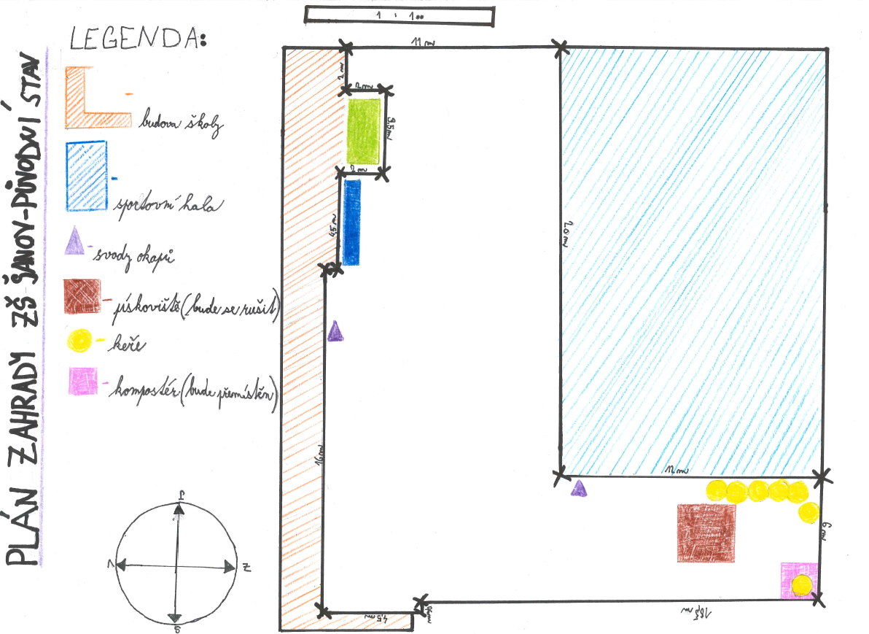
Picture 8 – Drawing of the existing fenced plot of the school garden

This part of the project was implemented as part of the teaching subject Physics with 6th grade students. The students took measurements with a tape measure in the field, then drew a plan of the garden, indicated the actual dimensions and attached a legend and a compass rose to the plan.
Recommendation: this procedure should be implemented within the framework of inter-subject relations physics – geography – mathematics.

Subsequently, after consultation with an expert, the garden elements that are suitable to be placed in the school garden area were determined. These are the following elements:
- herb garden,
- sunflower field,
- a bed of climbing beans,
- edible shrubs,
- field with roots,
- raised beds,
- stone wall.
After evaluating and analysing the data obtained from the weather station and micro:bits with sensors, the students determined the most optimal placement of individual garden elements in the school garden - see picture 9.
Picture 9 – Layout of garden elements on the school garden plot

4.th part of the project – Use of external modules in the investigation of physical quantities

Time requirement: each laboratory work is scheduled for 2 class hours Target group: Students from 5th to 9th grade of elementary school

In the final part of the project, we focused on the use of individual external modules in the laboratory activities in the lessons of the Physics subject.

Laboratory work – Measurement of air temperature during the day - see Appendix No. 1
Laboratory work – Connection of air pressure with weather development - see appendix no. 2

Attachment

Attachment n. 1
LABORATORY WORK
Temperature
Topic: Measuring air temperature during the day
Name: | School year:
Class: | Execution date:

Assignment:
continuously measure the outdoor air temperature every hour during any day
Tools:
outdoor thermometer (use data from the weather station located on the school campus or an external temperature measurement module connected to the micro:bit)

Method:
- During any day, record the outdoor temperature data in a chart.
- Answer questions about your measurement method.
- Write the temperature data in the chart.
- Enter the temperature data found in the graph.
- From the detected data, it calculates the average temperature during the day (arithmetic average is calculated as the sum of all measured values ​​divided by the number of measurements).

Solution:
On which day do I take the measurement (write down the date)? ____________________________
What device do I use to measure? ____________________________

Data on the measured temperature recorded in the table:
time (in hours) | 00:00 | 01:00 | 02:00 | 03:00 | 04:00 | 05:00 | 06:00 | 07:00 | 08:00 | 09:00 | 10:00 | 11:00 | 12:00 | 13:00 | 14:00 | 15:00 | 16:00 | 17:00 | 18:00 | 19:00 | 20:00 | 21:00 | 22:00 | 23:00 | 24:00
temperature (in °C)

Measured temperature data recorded in the graph:
Choose the correct option (cross out the wrong option):
put time – temperature in hours – in °C on the horizontal axis.
put time – temperature in hours – in °C on the vertical axis.

Calculation of the average temperature during the day:
number of measurements: ________________
sum of all measured values: ________________

Calculation:

Conclusion:

Attachment n. 2
LABORATORY WORK
Air pressure
Topic: Connection of air pressure with weather development
Name: | School year:
Class: | Execution date:

Assignment: during any day, measure the outside air temperature and atmospheric pressure regularly every hour

Tools: outdoor thermometer (use data from the meteorological station located on the school premises or an external module for measuring temperature and atmospheric pressure connected to the micro:bit)

Method:
- During any day, record the outdoor temperature data in a chart.
- During the same day, record the atmospheric pressure data in a chart.
- Record the dependence of air temperature on time and atmospheric pressure in the graph.

Solution:
On which day do I take the measurement (write down the date)? __________________________
What device do I use to measure? __________________________

Data on measured temperature and atmospheric talc recorded in the chart:
time (in hours) | 00:00 | 01:00 | 02:00 | 03:00 | 04:00 | 05:00 | 06:00 | 07:00 | 08:00 | 09:00 | 10:00 | 11:00 | 12:00 | 13:00 | 14:00 | 15:00 | 16:00 | 17:00 | 18:00 | 19:00 | 20:00 | 21:00 | 22:00 | 23:00 | 24:00
temperature (in °C)
pressure (in Pa)

Graph of dependence of temperature and atmospheric pressure on time:

Horizontal axis: recorded quantity _________________________
unit _________________________

Vertical axis: recorded quantity _________________________
unit _________________________

Additional information:
minimum measured temperature value: _________________________
maximum measured temperature value: _________________________
minimum measured value of atmospheric pressure: _________________________
maximum measured value of atmospheric pressure: _________________________
Conclusion:

