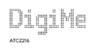
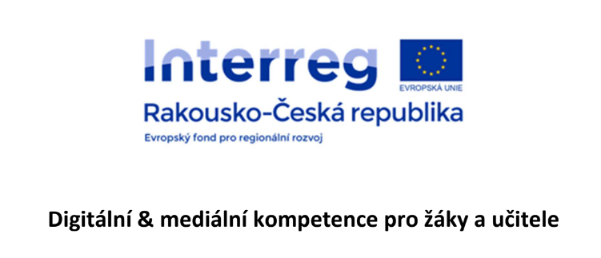
Digital and media competence for pupils and teachers

Water
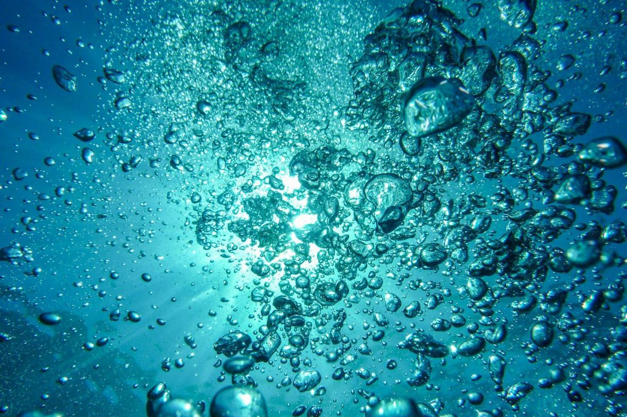
Instructions for implementation – finding out the properties of water, cleaning water, building a house that uses gray water

Annotation
Water

Using technology, pupils can get to know this life-giving liquid in detail, with which they are in daily contact.
To determine chemical and physical properties, they will use the environment case, the multidisciplinary set - substances in everyday life and the nanotechnology case. They will also make distilled water in the still and compare the differences with classic tap or rain water. A magnetic stirrer and magnetic stirring rods will be of great use when working with water. At the end of our project, the students will get to know the Hoffman apparatus, with the help of which and the acquired knowledge and skills, they will break down water (H2O) into separate elements.
The students will use their knowledge in their self-built house, which will recycle gray water.
Necessary equipment
PLA Material prusa different colors CZK 2,600
Original Prusa i3 MK3S+ 3D printer kit - compact full-size printer CZK 19,990
https://shop.prusa3d.com/cs/3d-tiskarny/180-stavebnice-3d-tiskarny-original-prusa-i3-mk3s.html?gclid=CjwKCAjwqvyFBhB7EiwAER786XBs_DYybSyVXYaDXSGM8ju8oLJE6CBmD4hxXdn4oZUHA5CWgw46PBoCNkAQAvD_BwE
Phone tripod 710 Kč
https://www.alza.cz/rollei-cestovni-stativ-pro-mobilni-telefony-a-fotoaparaty-d5236353.htm
EcoLabBox-environmental briefcase CZK 4,999
https://www.skolamarket.cz/EcoLabBox-kufrik-zivotni-prostredi-d18.htm
Multidisciplinary set of fabric in everyday life CZK 16,853
https://www.skolamarket.cz/Multioborova-sada-latky-v-kazdodennim-zivote-d180.htm
Nanotechnology case – NanoSchoolBox CZK 15,729
https://www.skolamarket.cz/Kufrik-nanotechnologie-NanoSchoolBox-d219.htm
Distillation apparatus Aqua Compact 7 360 CZK
https://www.sana-store.cz/destilacni-pristroj-aqua-compact-bily?gclid=Cj0KCQiA6Or_BRC_ARIsAPzuer-AhnJiNT2YANfIwLTT98N7yuY6QQVGlGPszpChKbQUGZxcHsCvblIaAv3TEALw_wcB
Magnetic stirrer without heating 5 199 CZK
https://www.skolamarket.cz/Magneticke-michadlo-MS-12B-bez-ohrevu-d662.htm#detail-anchor-description
Magnetic stirrer set 1 689 CZK
https://www.skolamarket.cz/Sada-magnetickych-michadel-d663.htm
Hoffman's apparatus for the decomposition of water 9 658 CZK
https://www.skolamarket.cz/Hoffmanuv-pristroj-na-rozklad-vody-d163.htm
Water purification kit 1 210 CZK
https://www.skolamarket.cz/Souprava-na-cisteni-vody-d671.htm#detail-anchor-description
wires 65 CZK
https://www.hwkitchen.cz/propojovaci-vodice-f-f-20-cm-40ks/
2x micro:bit set + micro:bit 3 660 CZK
https://www.hwkitchen.cz/bbc-microbit-kutilsky-kit/
micro:bit set + micro:bit 2 388 CZK
https://www.hwkitchen.cz/bbc-microbit-kit-pro-internet-veci-iot/
2x micro:bit set + micro:bit 3 872 CZK
https://www.hwkitchen.cz/bbc-microbit-kit-pro-chytrou-domacnost/
3x Temperature sensor 549 CZK
https://www.hwkitchen.cz/octopus-teplotni-cidlo-ds18b20-vodotesne/
2x PH sensor 2 038 CZK
https://www.tme.eu/cz/details/df-sen0161/cidla-environmentalnich-velicin/dfrobot/sen0161/
2x TDS sensor 898 CZK
https://www.tme.eu/cz/details/df-sen0244/cidla-environmentalnich-velicin/dfrobot/sen0244/
2x Turbidity sensor 768 CZK
https://www.tme.eu/cz/details/df-sen0189/cidla-environmentalnich-velicin/dfrobot/sen0189/

Total: 100 235 CZK

Time allocation
Meetings took place once a week from October 2021 to May 2022 for 90 minutes.

Number of students involved
Five pupils from the 7th and 9th grade took part in the project.
The 7th graders were in charge of designing and building the house.
9th graders programmed micro:bits, invented options for connecting a smart home
and installed the equipment in the house.
The teachers helped the pupils with the implementation of the project, acted as guides, let the pupils do research work and tried to find solutions in problem situations.

Project goal
The water project is focused on determining the properties of water using digital technologies and to find solutions for gray water recycling in the modern house. Pupils will learn to use their knowledge in everyday life and become more familiar with solving ecological problems.
Gray water
Gray water is sewage waste water that does not contain feces and urine, which drains from sinks, bathtubs, showers, sinks, etc. Gray water after treatment, especially the one from bathrooms, is possible to use as operating water (so-called white water) for flushing toilets and urinals and watering gardens, resulting in significant savings in sewage costs.
Greywater can be divided into several main categories:
- Unseparated greywater
- Gray water from kitchens and dishwashers
- Gray water from washing machines
- Gray water from sinks, bathtubs and showers
- Other gray waters

Fluctuations in pollution values, which result from different lifestyles, are characteristic. In general, it can be said that the least burdened are the waters from showers and washing, the use of water is more complex
e.g. from kitchens (water contains a lot of fat, etc. Gray water can be divided according to load to be suitable and conditionally usable for recycling and subsequent use. Water is usable from sinks, bathtubs and showers and conditionally usable from the kitchen area and dishwasher.
The reuse of gray wastewater is one of the ways to reduce the consumption of drinking water and reduce the amount of discharged water.

Equipment and its use
NanoSchoolBox
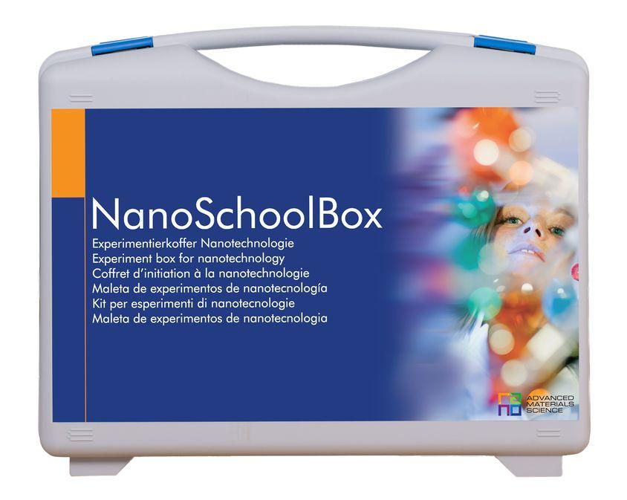
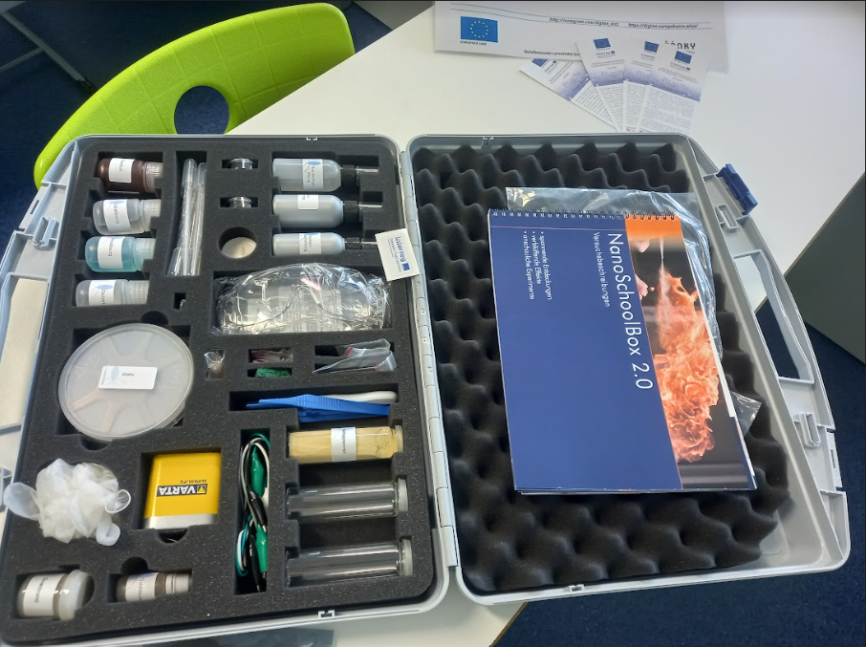
Use the NanoSchoolBox to discover the properties of water. You can make a hydrophilic surface on wood and fabrics. This technology can be used on modern houses to collect more rainwater.
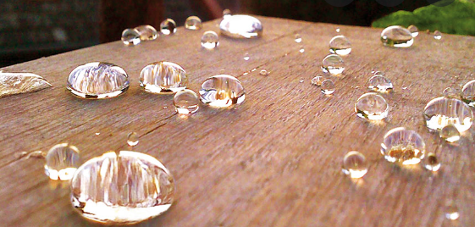
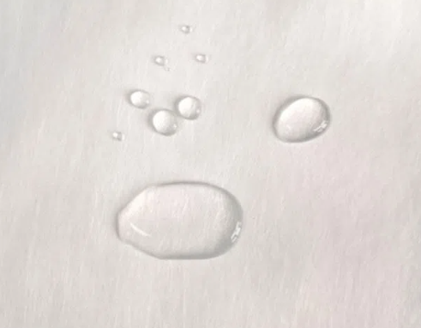

A multidisciplinary set of substances in everyday life
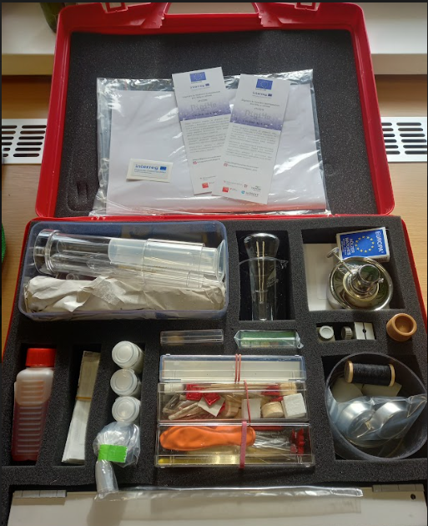
With the multidisciplinary set of substances in everyday life, you will find out the hardness of water, verify the density of water and compare tap water with distilled and gray water. You can clean, desalinate and filter gray water using the set. It is also possible to determine the state of water types when heated, and how the boiling point of water is affected with regard to its purity.
EcoLabBox
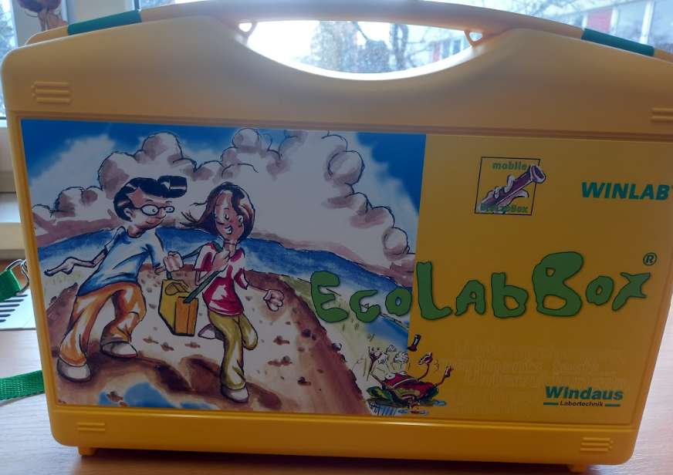
EcoLabBox will help you measure the pH of water, you can find out the content of nitrates, nitrites and phosphates in water.
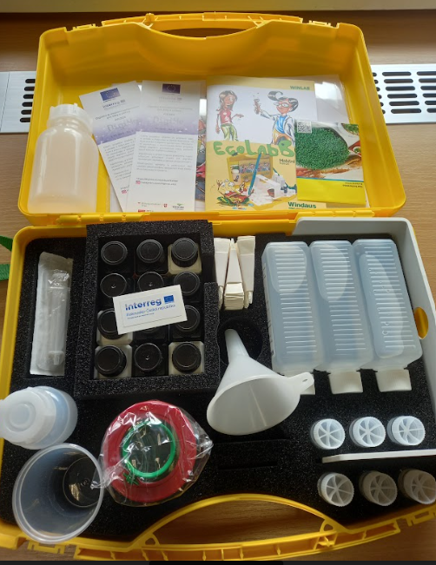
Distillation machine Aqua Compact
The device is used for water distillation. During distillation, water evaporates, which removes, among other things, organic compounds, heavy metals, chlorine, chloramine and radioactive nuclides. Distilling water uses heat to boil the water and create steam to kill any bacteria and viruses.

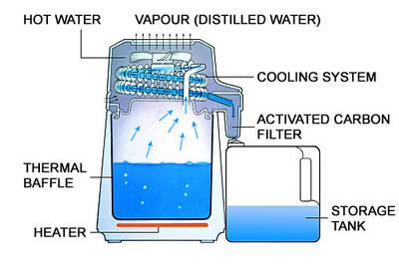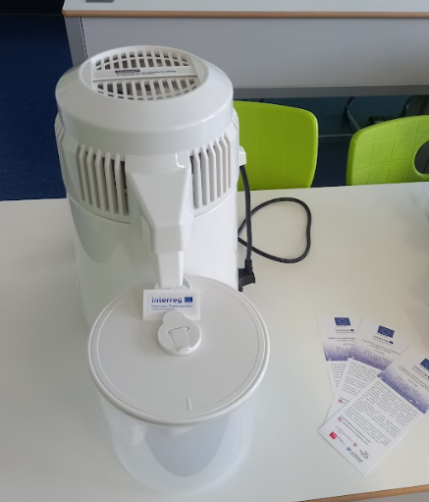

LABORATORY EQUIPMENT
The project is also intended to strengthen interest in ecology, chemistry, physics and other natural sciences, which is why pupils learn to work with a magnetic stirrer, which makes scientists' work easier and with which they don't meet in class. Furthermore, they can try working with Hoffman's device, which is also not part of the teaching. Pupils under the guidance of teachers can carry out laboratory work, namely the electrolysis of water with the help of Hoffman's apparatus.

Assignment of laboratory work
Electrolysis of water
Chemicals: concentrated H₂SO₄, distilled water
Gadgets: Hofmann apparatus, 12 V DC source, graphite electrodes, rubber gloves, dropper, 200 cm3 beaker, glass bath or two deep and wide bowls
Method
- close the device in the lower part with plugs with electrodes, place a glass bath under them, open both upper taps
- prepare acidified water in a beaker (about 2 cm3 H₂SO₄ to 150 cm3 water)
- Carefully¹ fill the Hofmann apparatus with acidified water H₂SO₄ to the top of the scale² (pour the solution in the middle of the upper part of the apparatus)
- now connect direct current with 12V voltage and let the electrolysis take place for about 2 minutes
- during that time, the solution in both arms will be saturated with the resulting gasses and the measurement will be more accurate
- close the taps
- about 5 times after approximately five to ten minute intervals, read the volumes of gasses produced at the electrodes
- end of work: put on gloves, check that there is a glass tub under the device, SLOWLY open the taps
- carefully and slowly pull out one electrode while wearing gloves over the bath, the H₂SO₄ solution will flow out into the bath, then pull out the other electrode in the same way (to drain the rest of the solution)

Filling Hofmann apparatus
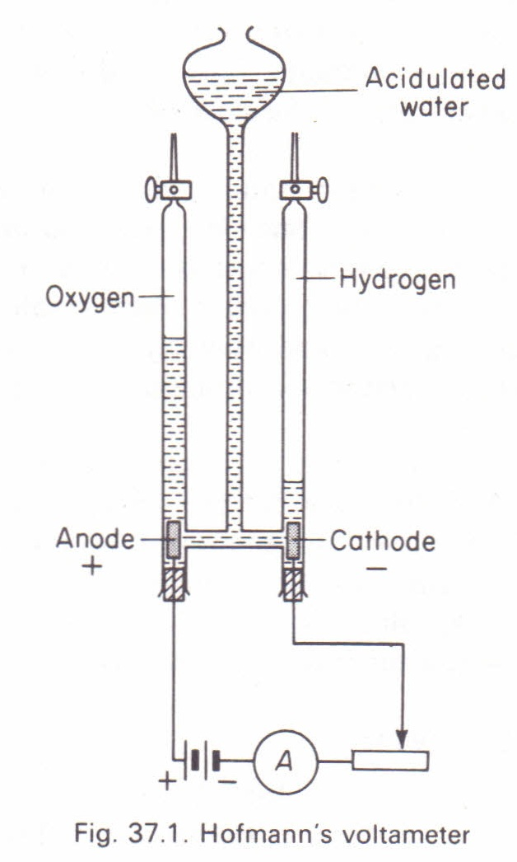

Tab. 1: Measurement record (dependency of the volume of gases formed on time)
Čas | cm³ H₂ | cm³ O₂ | cm³ H₂ : cm³ O₂
¹Acidified water (dilute H₂SO₄ solution) must not get into the eyes. Unlike a burette, it is not possible to sensitively regulate the level of the liquid in the Hofmann apparatus using a tap. Therefore, the acidified water must be added slowly in the final phase.
²The school instrument has the first marked volume value at 2 cm3. We will therefore choose the initial position of the level at 2 cm3 and we will subtract this value during further measurements.
³When opened quickly, the level of the liquid in the device fluctuates and there is a risk of it splashing out and getting into the eyes. For this reason, it is necessary to open the taps slowly.

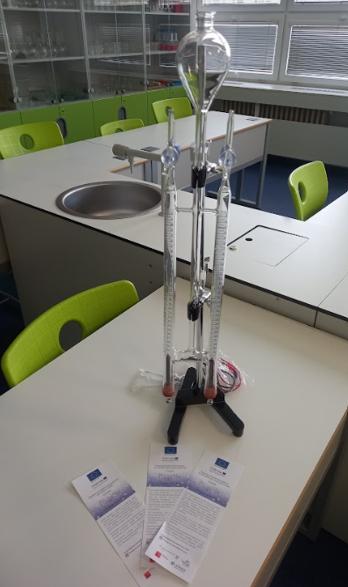
Micro:bit
For programming, it is necessary to learn to work in the micro:bit microcontroller programming environment. You can find it here: https://makecode.microbit.org/.
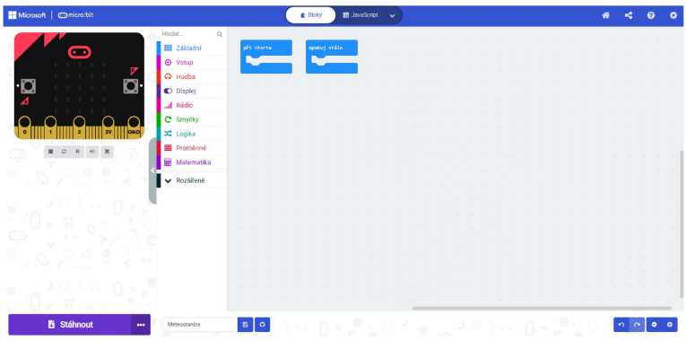

Pupils will learn to work in the Scratch educational programming language under the guidance of teachers.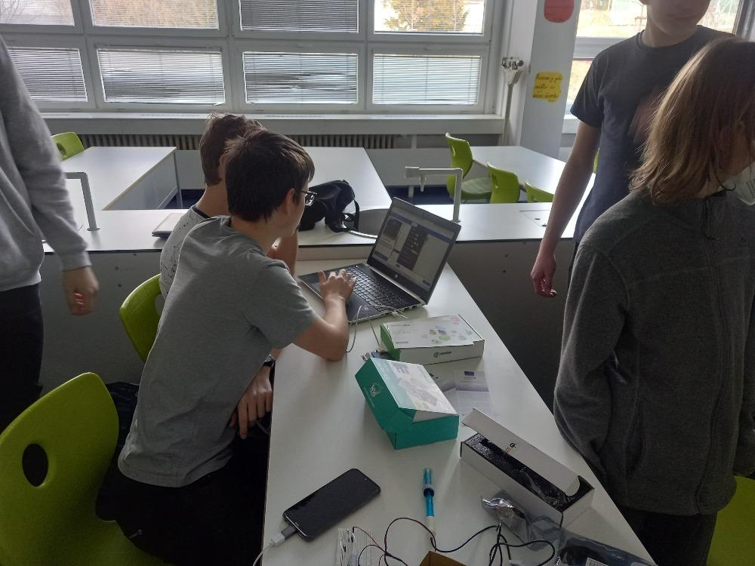
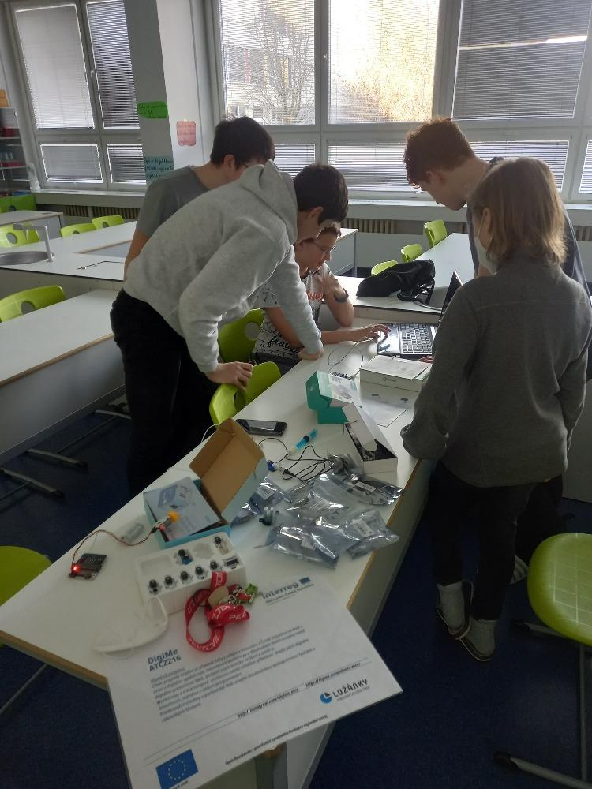

3D printer
Our first encounter with 3D printing was the assembly of a kit 3D printer Original Prusa i3 MK3S+. Under the guidance of teachers, students can assemble a 3D printer and save a considerable amount of money thanks to their own work.
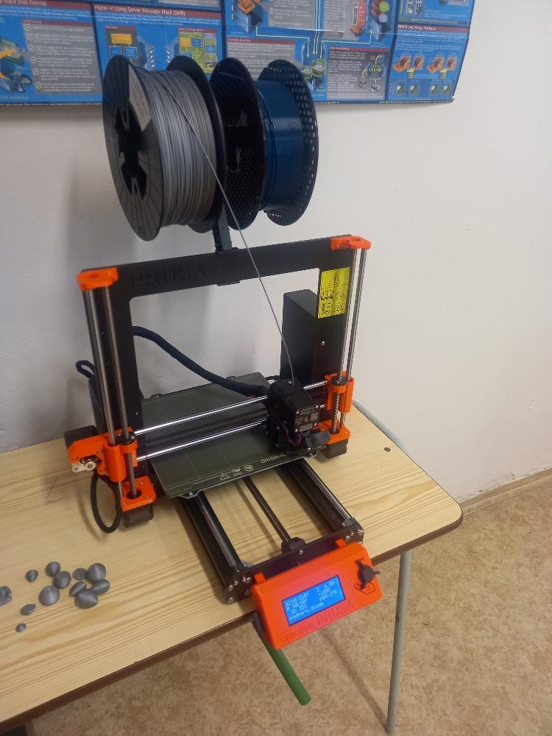
It is also necessary to learn 3D printing programs.
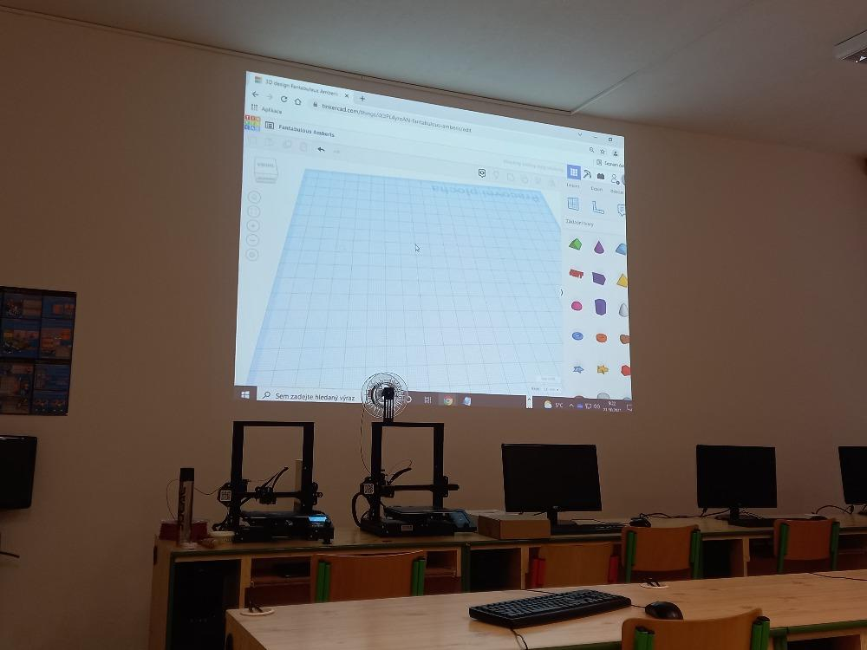
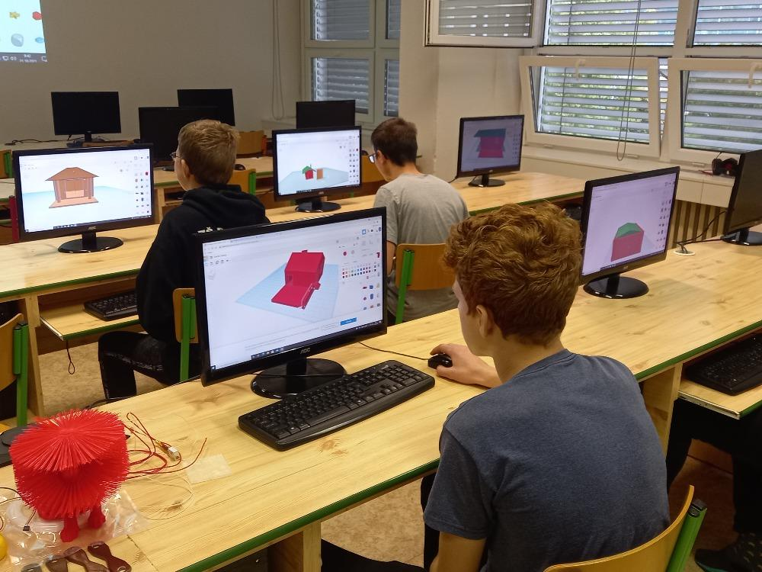

House construction
The basis of a modern house that can recycle gray water is the correct layout of the rooms. It is important to think about where the technical room will be located, it is also necessary to connect the rooms where the gray water will flow.
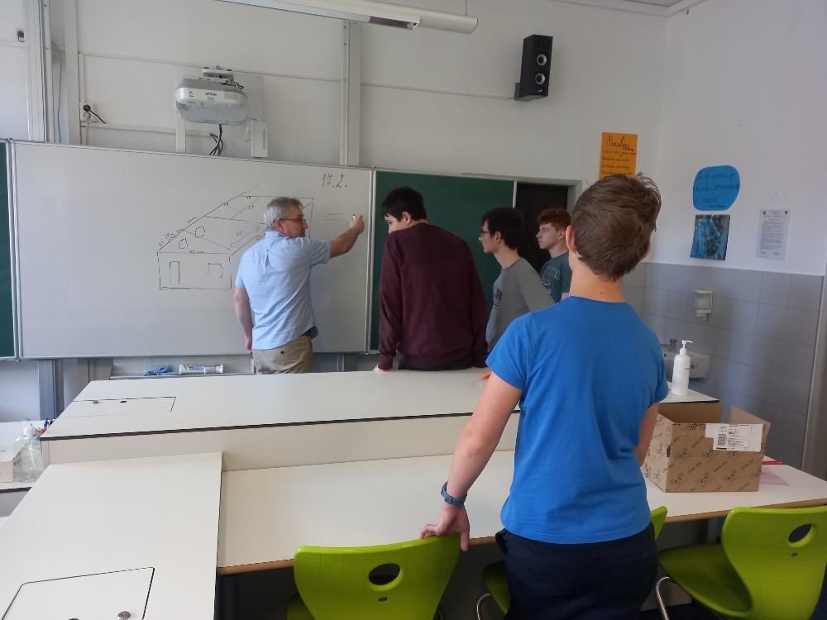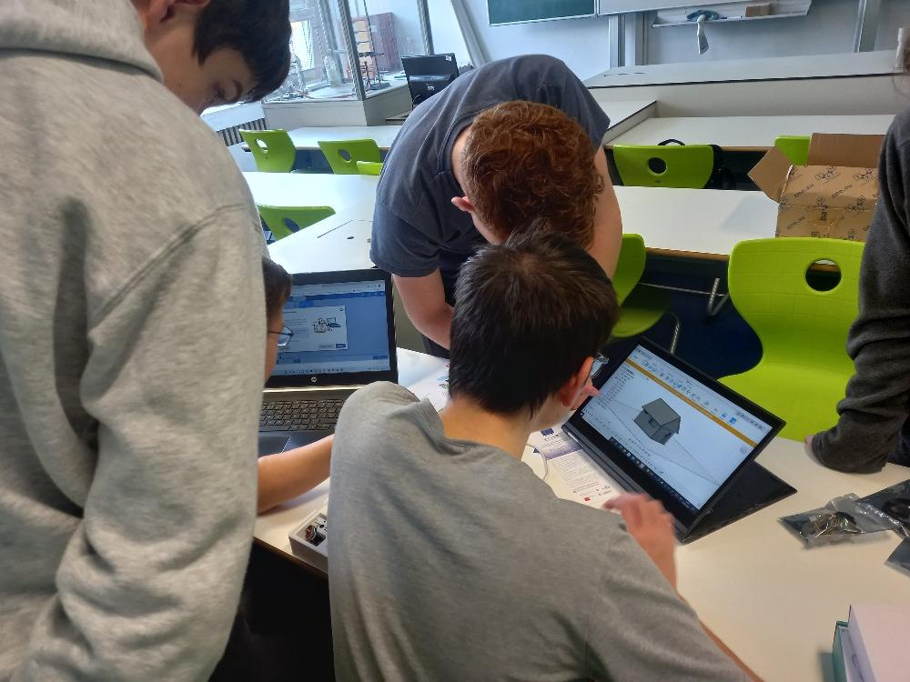
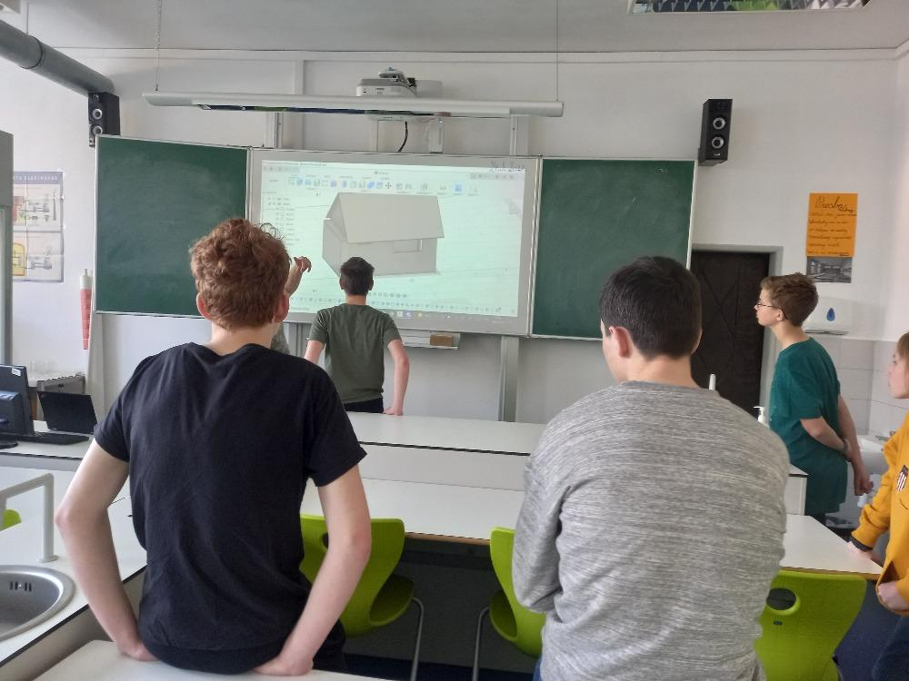
The construction of the house is made of OSB boards, which are laser-cut according to the design. For better stability, the boards are glued together.

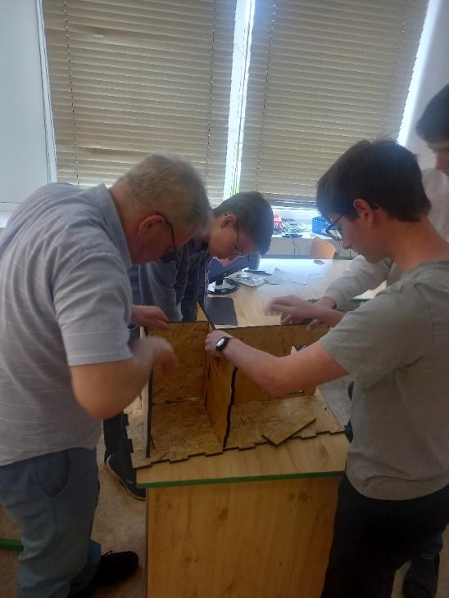
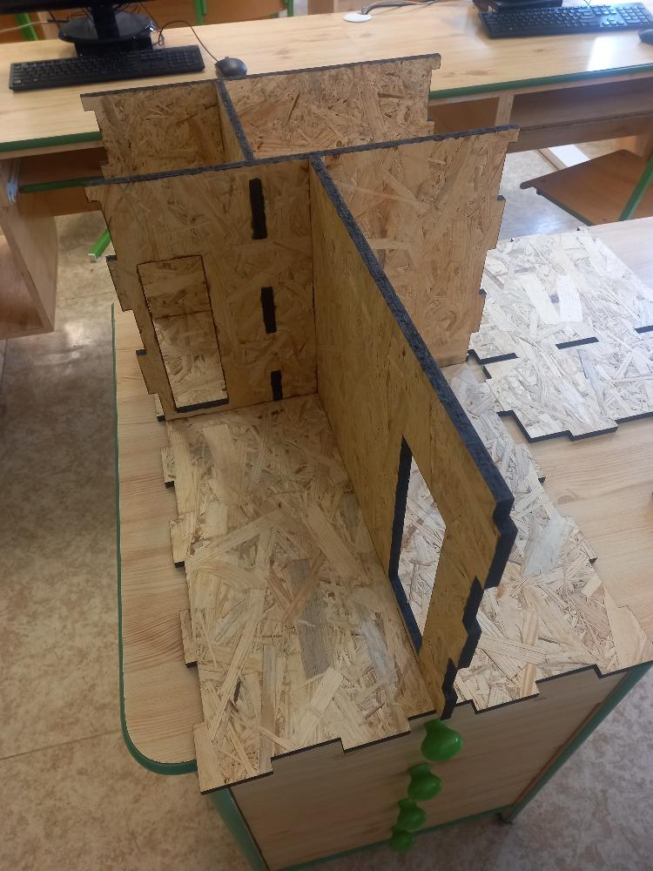
Another important part of the house is the roof, from which rainwater will be collected. For the most efficient collection of water, it is necessary to cover the roof with a hydrophobic material, which will ensure maximum rapid movement of rainwater into the retention tank.
Designing the water distribution in the house.
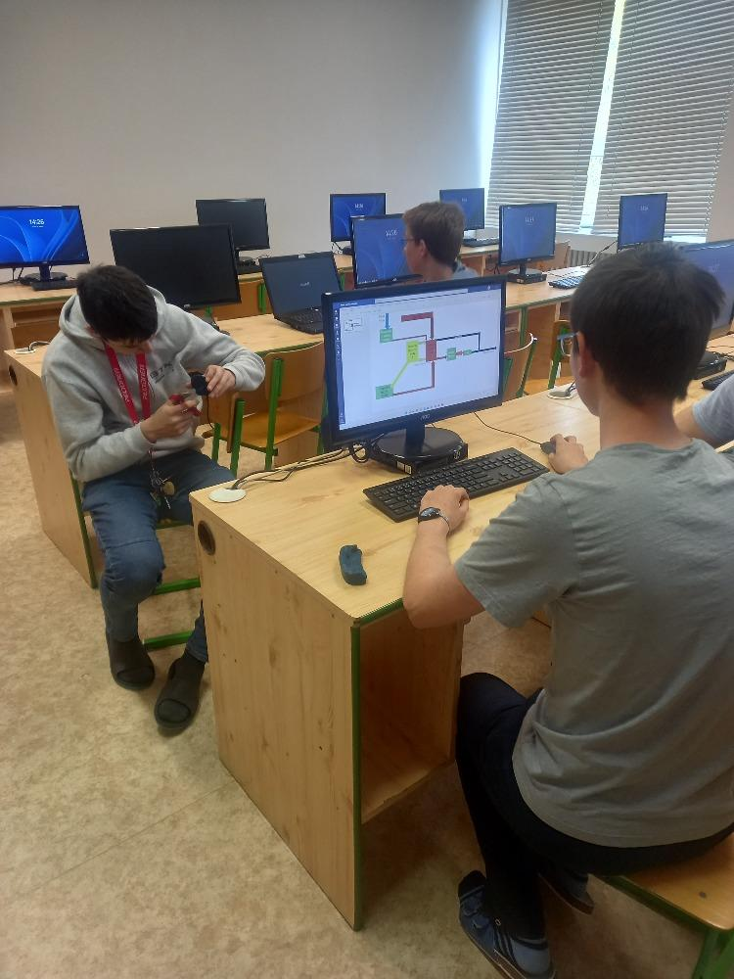

Designs and printing of individual components for the house.
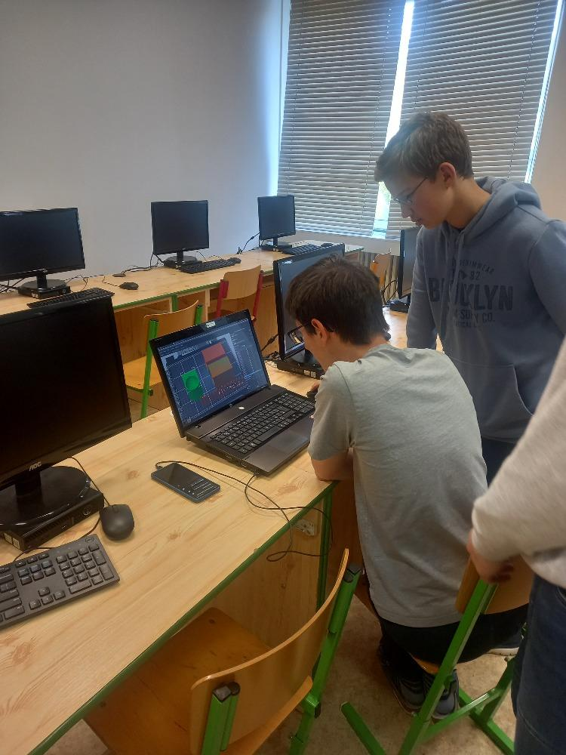

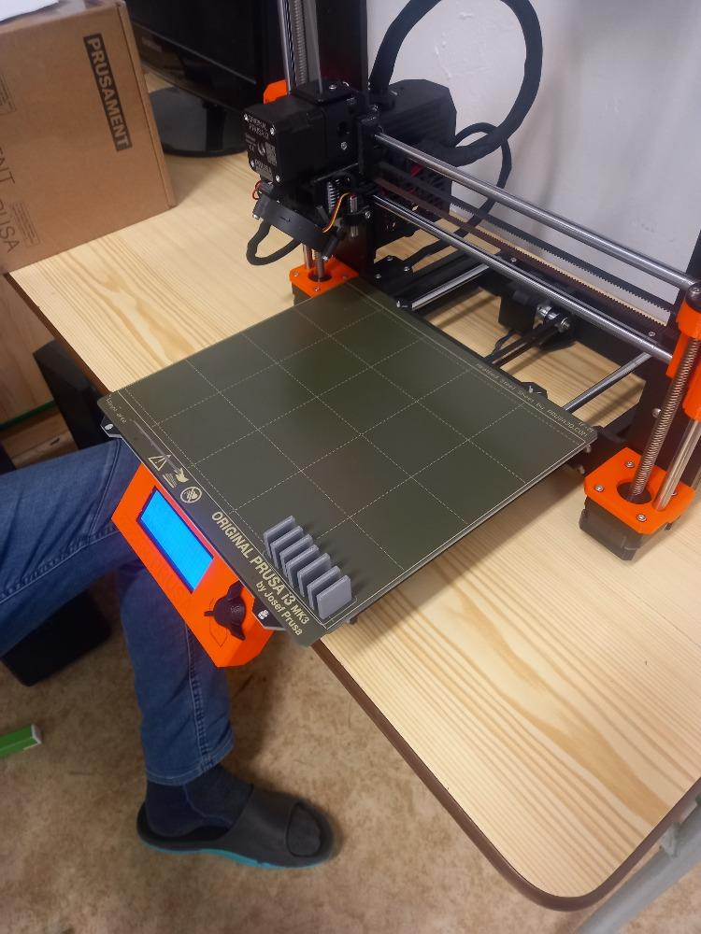
Supports for the technical room of the house.
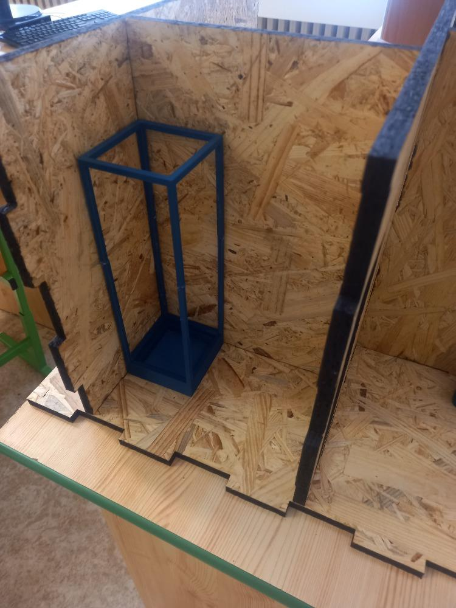
A shower in the bathroom with a drain to a retention tank, where the water will be cleaned for further use.

From the retention tank, which collects rainwater and waste water (outside the toilet), the cleaned water is led to the toilet in the house and to the tank for watering the garden. For this, it is necessary to program the pump using the micro:bit.
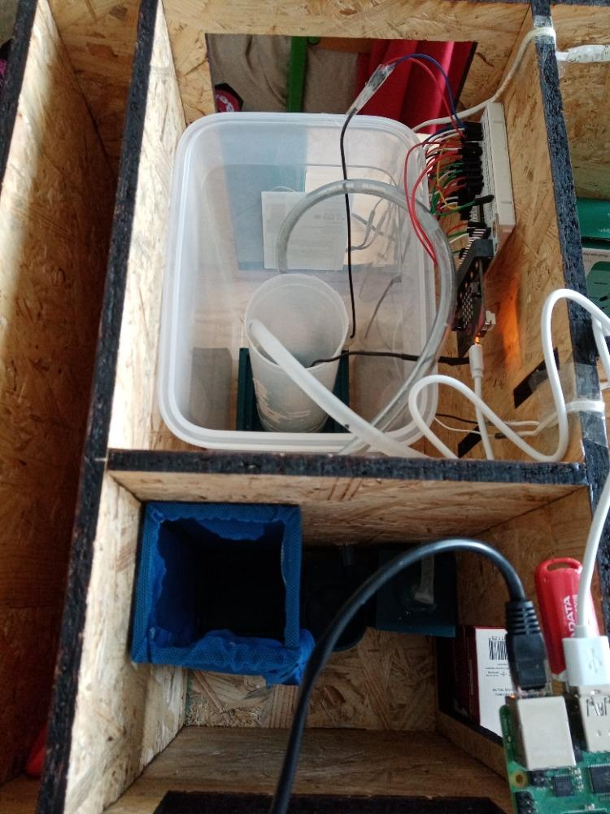

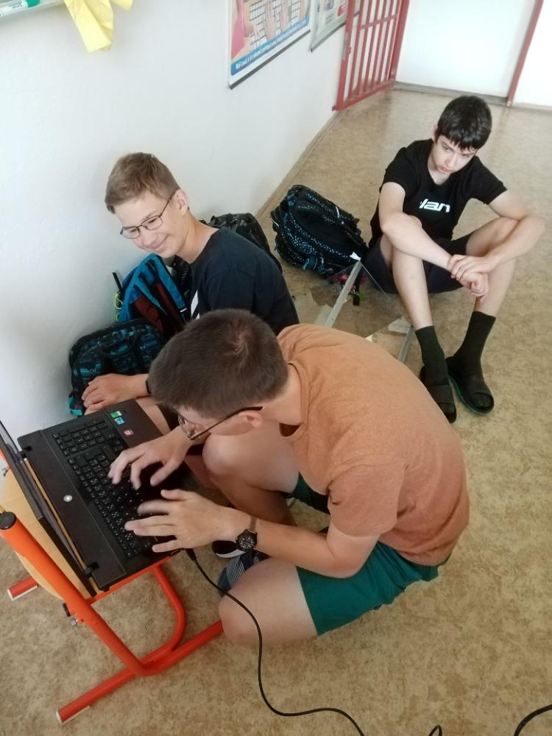

In order to see everything clearly, connect LED lights to the house, which will be controlled with a micro:bit.
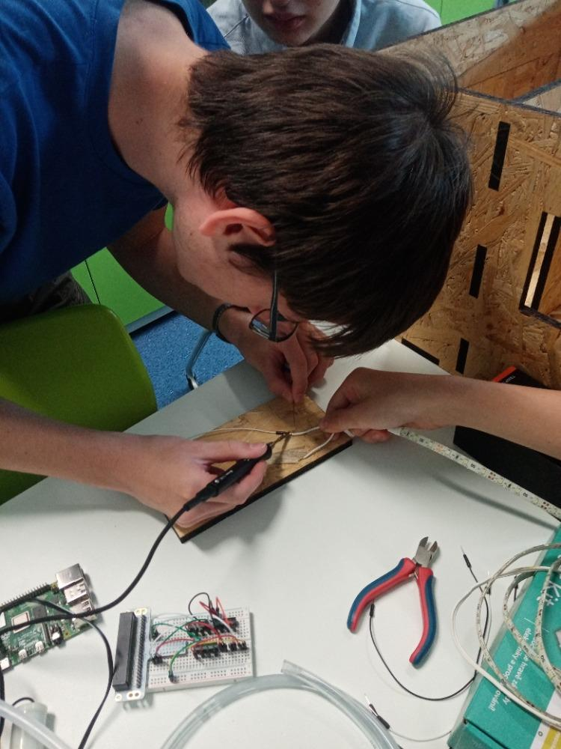
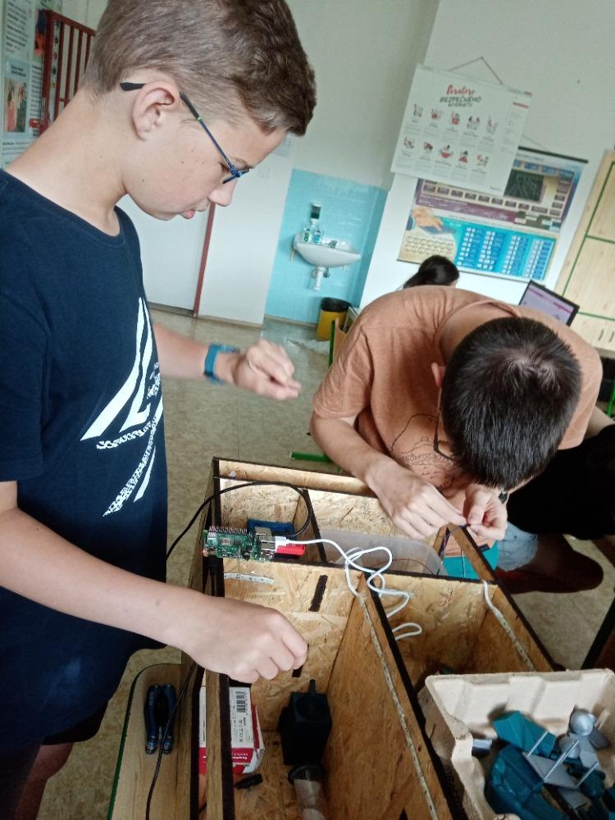

Smart home
Using the micro:bit Smart home Kit, it is possible to further program the following functions:
- Sound controlled lights
- Smart cabinet
- Automatic maintenance of the water level in the aquarium
- Smart fan
- Noise level meter
- A simple alarm
You can find all the instructions here.
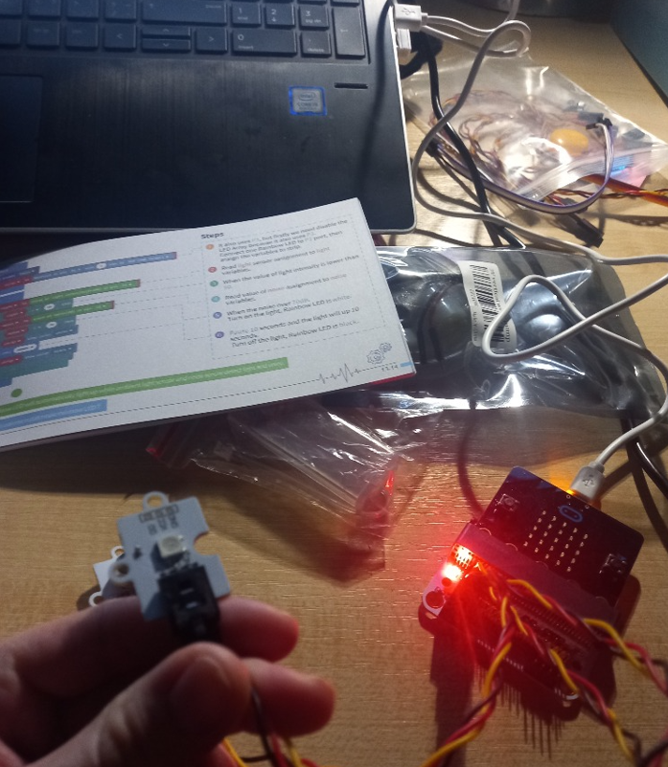

Sustainability of the project
The equipment purchased from the DigiMe project serves the pupils of our school to acquire digital competences in the subjects of computer science, physics, chemistry, work activities and art education.

Presentation of the project
We used our website to present the project:
3D printer
We have it! It's already ours too! We can start 3D printing! But we would never have built it without the help of clever parents. Thank you
Our school participates in the DigiMe project, thanks to which we were equipped with technology worth CZK 100,000. We got a 3D printer, micro:bits, cleaning kits, to investigate the physical and chemical properties of water and many other conveniences.
During the following months, a group of pupils will investigate the world's most important liquid - water. We will try to come up with a solution to protect, save and clean water. We will make our own 3D model of our subjects. We will be happy to show you our ideas and research during the evaluation of the project in June 2022. Here we will meet with other schools and try to win 1st place for the originality of the project and professional processing.

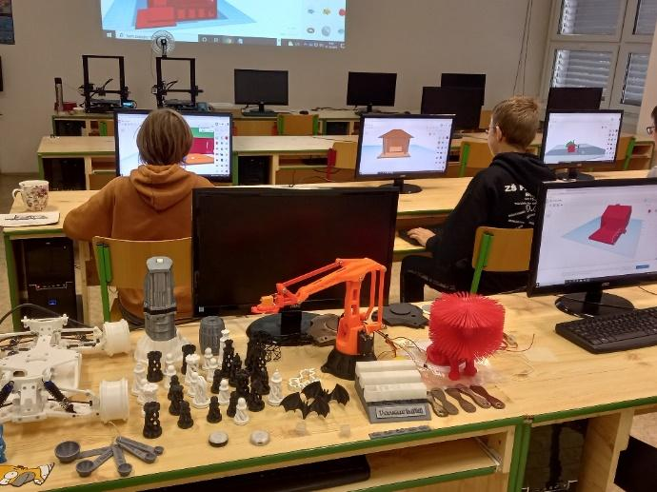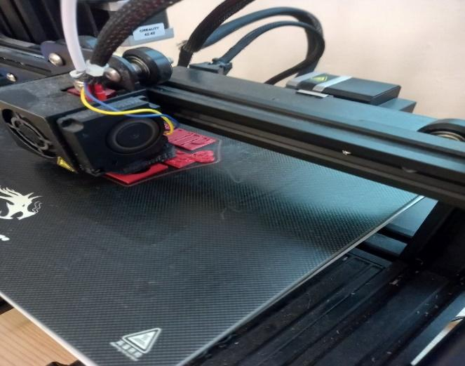
Workshop - 3D Printing
Selected enthusiasts from among our students experienced first-hand what 3D printing entails at school on 21 October 2021. And why does it exist?
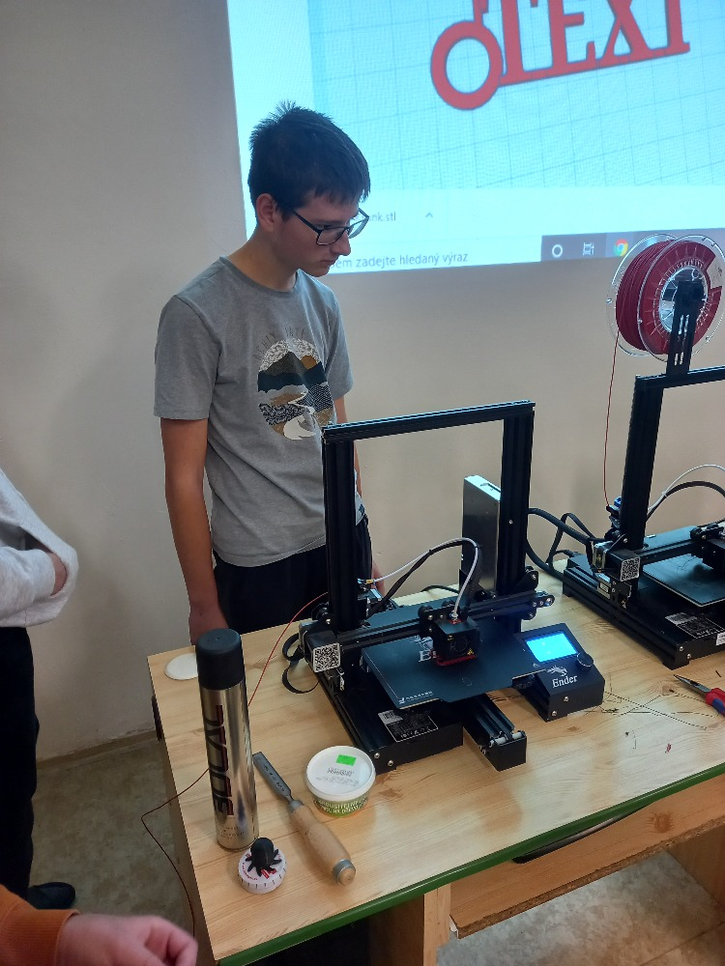
This year we joined the DigiME project. The project is focused on digital technologies that teachers will be able to use in their lessons. Among other things, with a 3D printer and microbits. For some workshop participants, 3D printing was not new, and they enthusiastically shared their experience and knowledge with the lecturers. In four lessons, we were not only introduced to the theory, but we designed and printed a keychain ourselves. Maybe 3D printing looks easy. When you try it yourself, you'll be surprised how challenging it is.

