R.U.R

Veselí nad Moravou elementary school, Hutník 1456, Hodonín district, contribution organisation
Hutník 1456, Veselí nad Moravou, 69801
Contents:
Project information 3
Project description 3
Target group 4
Entry requirements 4
What students will gain 4
Equipment and material 4
Financial complexity of the project 4
Project preparation 5
Preparation of pupils 5
Preparation of students who have not taken Scratch programming lessons 5
Preparation of pupils who have completed Scratch programming lessons 8
Implementation of the mechanical part 10
Production of basic parts of the house 10
Assembly of the house 15
Kitchen 21
Bedroom 23
Living room 24
Wind power plant 25
Roof 26
Connections, programs 26
Bathroom 27
Bedroom 28
Cradle 29
Living room 30
Cabinet 31
Kitchen 32
Refrigerator 33
Ventilator 34
A topic for further work 35

Project information

Project description
The project is used to acquire knowledge and skills in the field of robotic systems. We will try to equip our students with these skills, because there is a lack of qualified workers on the labor market, able to work with these systems, and thus contribute to the competitiveness of our graduates. Another activity of the project is to arouse interest in technical fields with a focus on automation and robotics. Modern robotic kits and teaching materials, which we intend to purchase as part of the project, will help us achieve this goal. Furthermore, the project has the task of finding talented pupils with an interest in programming and supporting their interest in technology. The entire project is realized as a replica of a doll's house, which was influenced by functionalism and was created in the 1930s, the house was purchased in the mid-1930s by the wife of the director of the Commercial and Industrial Bank in Prague, it is currently in the Central Bohemian Museum in Roztoky near Prague.
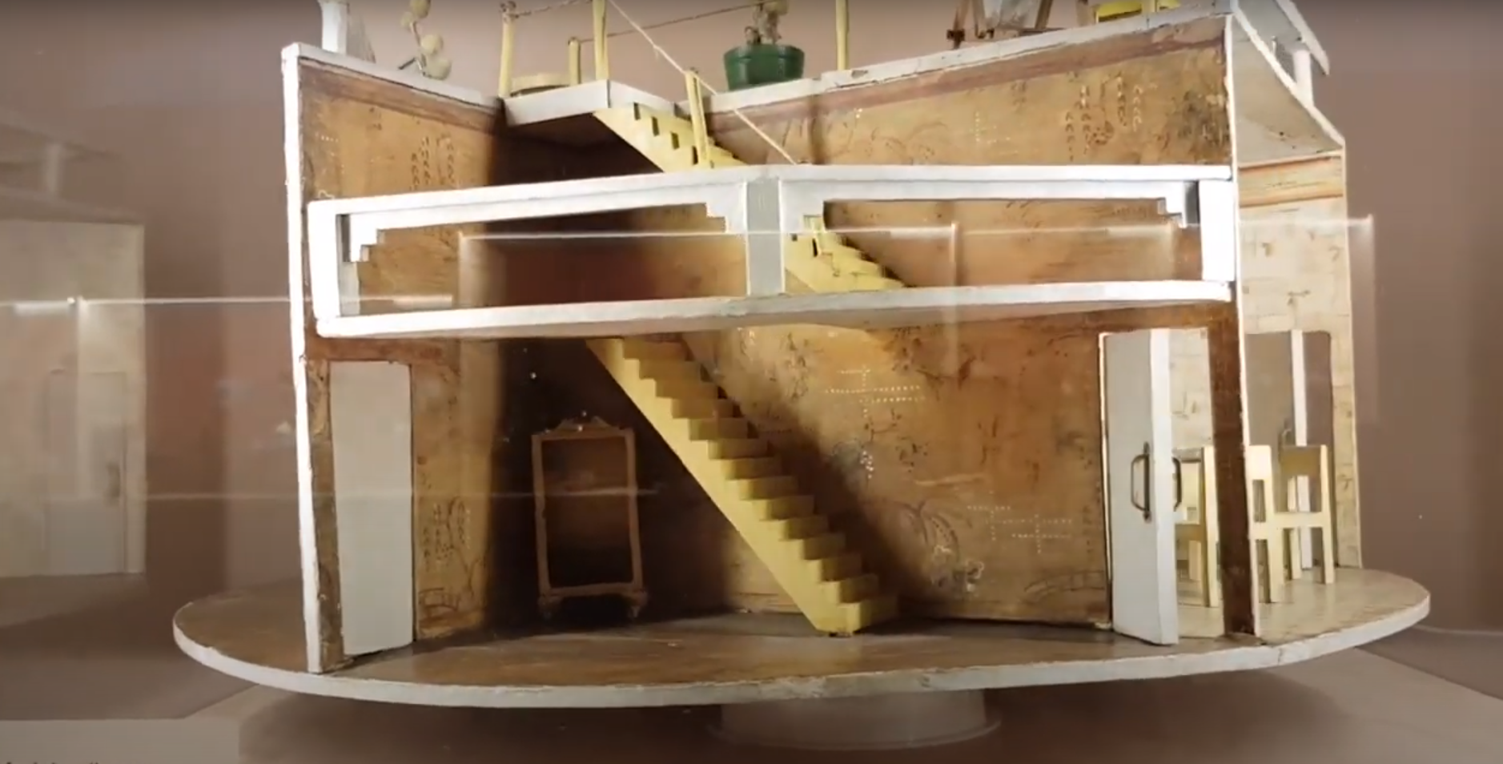

Target group
- Pupils of the 2nd grade of elementary school

Entry requirements
- Manual dexterity
- Basic knowledge of computer technology
- Desire to learn new things

What students will gain
- Basic knowledge of algorithmization and programming
- Teamwork experience
- Habits when working with machining tools (saw, rasp, sandpaper)

Equipment and material
- Wood saw
- Rasp
- Sandpaper
- Brushes, rollers
- Wood paint, preferably water-dilutable white – it does not smell, it is ecological
- Connecting material – screws 3x15, 3x30
- Building kit Merkur
- Building kit iTriangl
- Micro:bit Smart home kit
- Pulled to the servers – straightened paper clips
- Micro:bit board
- Board power supply – Belkin B2B139vF USB power station is used, it is possible to replace the power supply with cells from sources that are part of the Micro:bir Smart home kit
- Room equipment (dolls, children's furniture – sofa, armchairs, refrigerator, stove, wardrobes, bathtub, water tank, cradle, stroller)
- Styrofoam, hobra, polystyrene, paper roll (left over from foil)

Financial complexity of the project
- The mechanical part – all the components that were used can be found variously in the school, cellars, attics and containers.
- Merkur construction kit – find of various remains in the school club, used for assembly of relay holders and fans
- The iTriangl building kit – acquired during the implementation of the Fresh Wind from the Mountains project, was used to create a wind power plant on the roof of the house.
- Micro:bit board, price approx. 550 CZK (depending on supplier)
- Micro:bit Smart home kit, price approx. 1600 CZK (according to supplier)

Project preparation

Preparation of pupils
Pupils of different age groups participate in the implementation of the project, who therefore have different entry requirements. So we can divide them into two groups.
They completed the Scratch course
They haven't taken a Scratch course

Preparation of students who have not taken Scratch programming lessons
These pupils have not yet encountered programming. These are pupils of the 6th and 7th grade of elementary school who are starting from scratch. A kit based on the micro:bit Smart Cutebot was chosen for familiarisation with programming. They assembled the vehicle according to the attached instructions, fitted it with a power supply (3 AAA batteries) and connected the micro:bit board). The first step was to teach the robot to drive. They followed the instructions included with the kit.
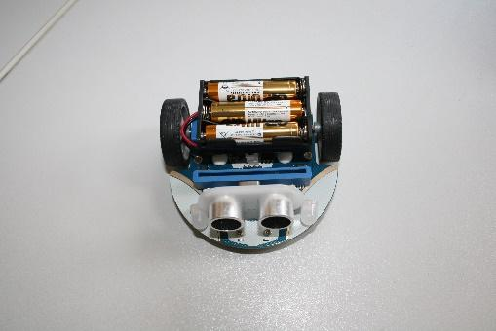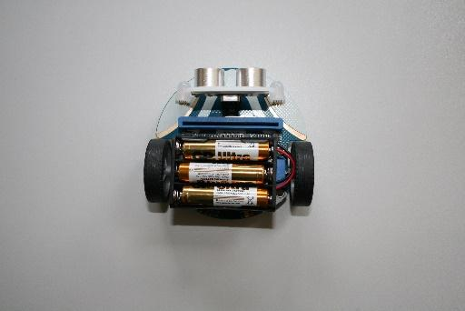
All it takes is a simple program
The next step was to teach the robot to turn
We continued using the ultrasonic sensor and stopped in front of the obstacle. We created a sonar variable and set the distance unit. The measured distance from the obstacle is stored in the variable. Here it is necessary to discuss with the pupils what a decision block is and how it is used. The measured distance must be within a certain range, so it is good to explain at the same time what is logical and what not. Another novelty is the division of the program into two blocks – at start and repeat all the time. The result is the truck stopping in front of an obstacle.

Next assignment – the robot backs up and avoids the obstacle. We solve this task gradually, in at least two lessons. In the process, we are also experimenting with the possibility of using "set left wheel speed right wheel speed" instead of turn left at full speed.
Next assignment – ​​the robot backs up and avoids the obstacle. We solve this task gradually, in at least two lessons. In the process, we are also experimenting with the possibility of using "set left wheel speed right wheel speed" instead of turn left at full speed.
Finally, we let the students program the robot according to Lesson 5 from instructions. The package also includes a track along which the robot then travels. We put an obstacle in the track, and according to the previous example, the robot avoids it and continues on the track.
After mastering the basics, we will give the students time to experiment with the robot, there are 5 lessons in the instructions, which they can go through independently and learn to control the display micro:bit, the light of the robot and the blin covers.
After completing these lessons, the students are ready to join the implementation of the project with their older friends.

Preparation of pupils who have completed Scratch programming lessons
The programming environment Scratch and makecode are very similar. The transition is therefore very easy for students. The fundamental difference is that in the makecode environment we are able to control other sensors and actors through additional accessories. We will use the Starter Kit to get acquainted with the possibilities of such work.
The Starter Kit includes, among other things, a micro:bit module for contact fields and contact fields. Using these components, we are able to directly program connected electronic components, e.g. LEDs, via the micro:bit.
For an initial introduction to programming options, we will use task No. 1 from the Starter Kit Guide. After connecting the circuit according to the diagram, the two connected LEDs blink alternately. Pupils will realise that it is necessary to connect components to precisely given pins, which they will then program.
In the next step, students will be introduced to the sensors and actors that will be used during the implementation of the project. It is about:
- Temperature sensor
- Sound sensor
- Light sensor
- Servo 180°
- Submersible pump
- Humidity sensor
- RGB LEDs
- DC motor
Pupils will learn to connect them via sensor:bit.
Attention! Some pins are reserved by the system and should be avoided. These are pins P3-P10 (OLED display), they can only be used if the LED function is turned off. Pins P5 and P11 are reserved for A and B buttons on the micro:bit, Pins P19 and P20 are reserved for the motion sensor on the micro:bit, best not to use them!
The students are divided into four groups according to the rooms they will program.
- Bathroom – submersible pump, humidity sensor, DC motor and temperature sensor
- Bedroom – servo, sound sensor, DC motor and temperature sensor
- Kitchen – servo, RGB LED, sound sensor, DC motor and temperature sensor
- Living room – servo, sound sensor, light sensor, RGB LED, DC motor and temperature sensor
Each group will first learn how to connect the assigned devices. We proceed gradually - it is best to start with a serve.
Here, the leader acts as a tutor, guides the students to find the right solutions and consults with them about problems. This is work with a group of gifted students.
Instructions for working with used kits can be found on the supplier's website
- https://www.hwkitchen.cz/cutebot-microbit-chytre-zavodni-auto/
- https://www.hwkitchen.cz/bbc-microbit-starter-kit/
- https://www.hwkitchen.cz/bbc-microbit-kit-pro-chytrou-domacnost/
At the bottom of the page there are links to wiring examples that redirect to the manufacturer's website elecfreaks.com, the instructions are in English in the form of lessons.
We will divide the work into a few hours, focusing mainly on the components used in the project. However, more advanced students have no problem mastering the entire kits and at the end of the preparation they design various applications independently.

Implementation of the mechanical part

Production of basic parts of the house
The house consists of the following parts:
- Base plate – material polystyrene, thickness 10 mm
- Walls of rooms 2 pcs – material rear solid-lithium board of cabinets, thickness. 5 mm
- Ceiling – Hobar material thickness 12 mm
- Dilation rollers 4 pcs – material hard paper, used foil roller
- Roof – material solid-stone board, thickness 5 mm
- Relay holders 5 pcs – kit material Merkur (metal)
- Fan holders 4 pcs – kit material Merkur (metal)

Base plate
According to the attached drawing, a circle is cut out of the polystyrene plate (with a knife, saw, hot cutter), which is then sanded with sandpaper and painted with white paint.

Φ 1000 mm

The walls of the rooms
We cut out a rectangle from the solid-lithium board with a saw, into which we make a saw cut according to the attached drawing. Clean with sandpaper and paint white. We will make one more piece anyway.

7 mm
1000 mm
450 mm
225 mm

Ceiling
We cut out the ceiling from the hob. Attention, there is a hole inside, where we will then pass the power cables through. According to the drawing, we drill holes at regular intervals for passing the control cables of the fans. Crosswise, we make 2 cuts in the ceiling with a hacksaw. 1 mm and 6 mm wide, serving as fixation to the walls of the rooms. Clean all the cuts with sandpaper and paint the ceiling.

4 x Φ 10 mm

Φ 700 mm
Φ 420 mm

30 mm

Expansion cylinders
We cut from a paper cylinder on which the foil is wound. The diameter of the cylinder is usually 50 mm, we choose the length so that it is possible to handle the cables freely, a suitable length is 50 mm. We clean the cuts again and paint them.
Roof
We cut the roof out of the solid-lithium board, clean the edges again and paint the ceiling.

Φ 530 mm

Relay holders
We will create a Merkur from the kit by connecting simple angles with two holes and parts. We need 4 pcs.

Fan mounts
We only use separate u parts.

Assembly of the house
We will start by assembling the walls of individual rooms. Both parts are connected together by inserting the notches into each other. A cross will appear, which we will place on the base plate.

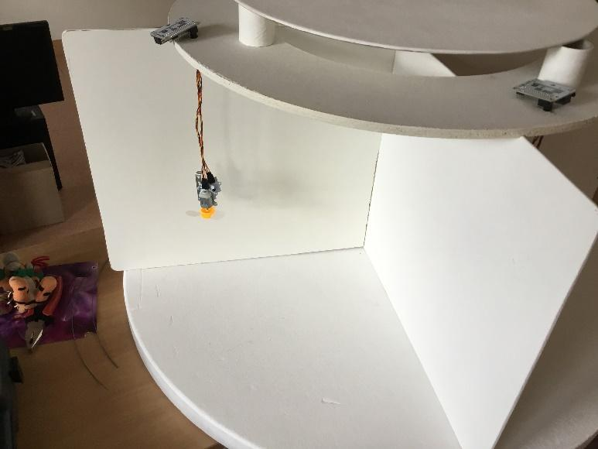

We will prepare the ceiling. We thread the control cables for fans and thermal sensors through the drilled holes.
We carefully screw the enzor to the fan using washers with an M3 screw with a nut at the same time as with the part from the Merkur kit.
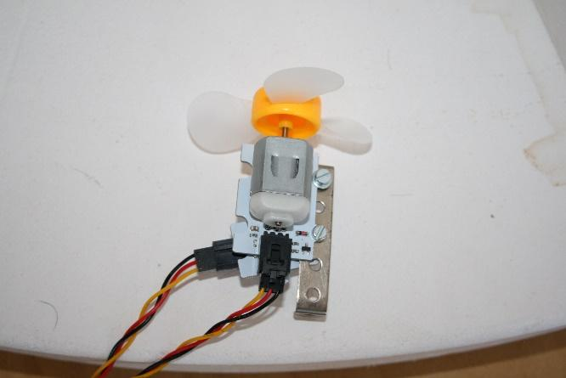
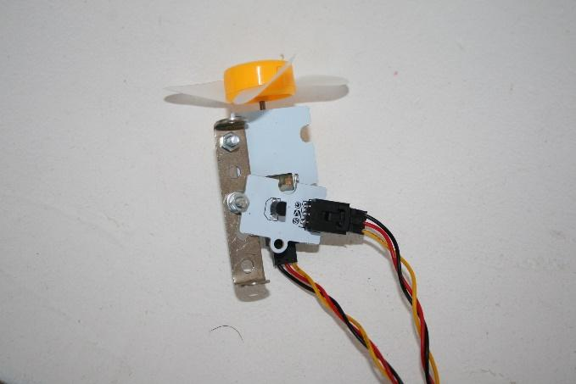

We place the Sensor:bit on the upper part of the ceiling (an expansion board for the Micro:bit that allows connection to sensors and actuators, only the designated pins can be used for different devices - see the description of the Sensor:bit) and connect the control cables. We screw a fan with a heat sensor to the lower part of the ceiling with a 3x15 screw. We connect the power cable. We will do this 4 times.
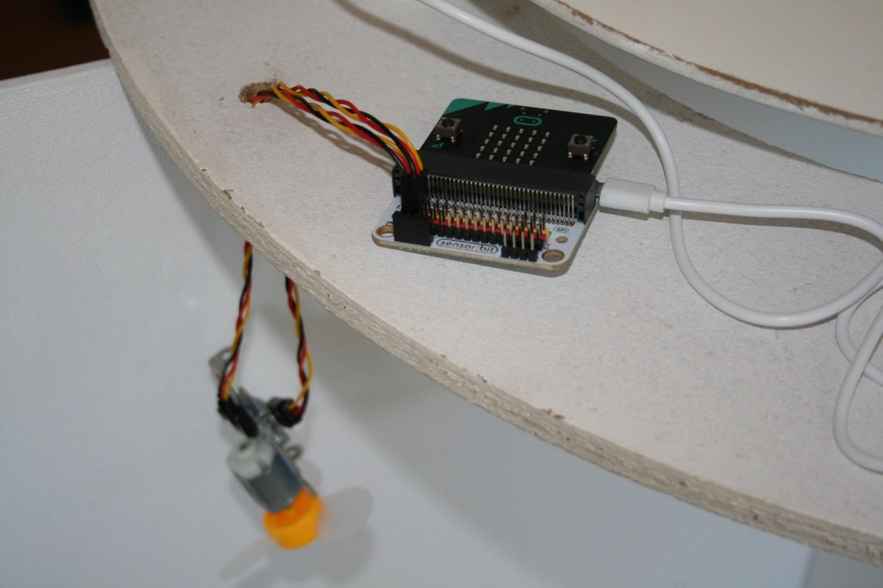
We will mark the individual rooms on the base plate and walls and dismantle the walls. In the living room, kitchen and bedroom, we screw 3x15 Sensor:bit screws onto them so that the control cables reach the servos, sensors and light. In the living room, we also screw the light to the wall with a 3x15 screw.
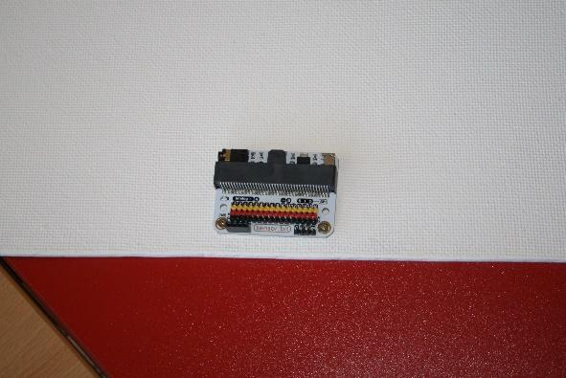
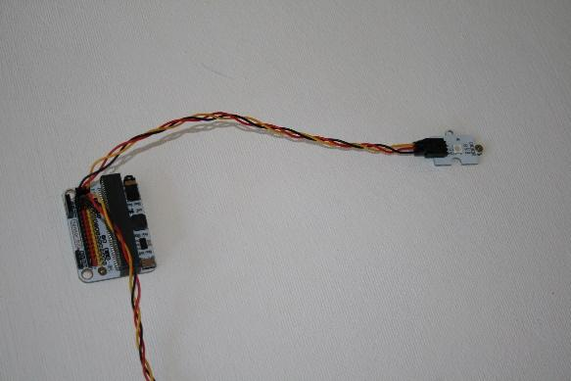
The exact location of all components depends on the furniture used. All we have used are various findings in the group, with colleagues, pupils, etc.
Fold the walls again and place them on the base plate. We will start completing the individual rooms.
Bathroom
Let's start with the bathroom. This mainly includes the bathtub and the water tank.
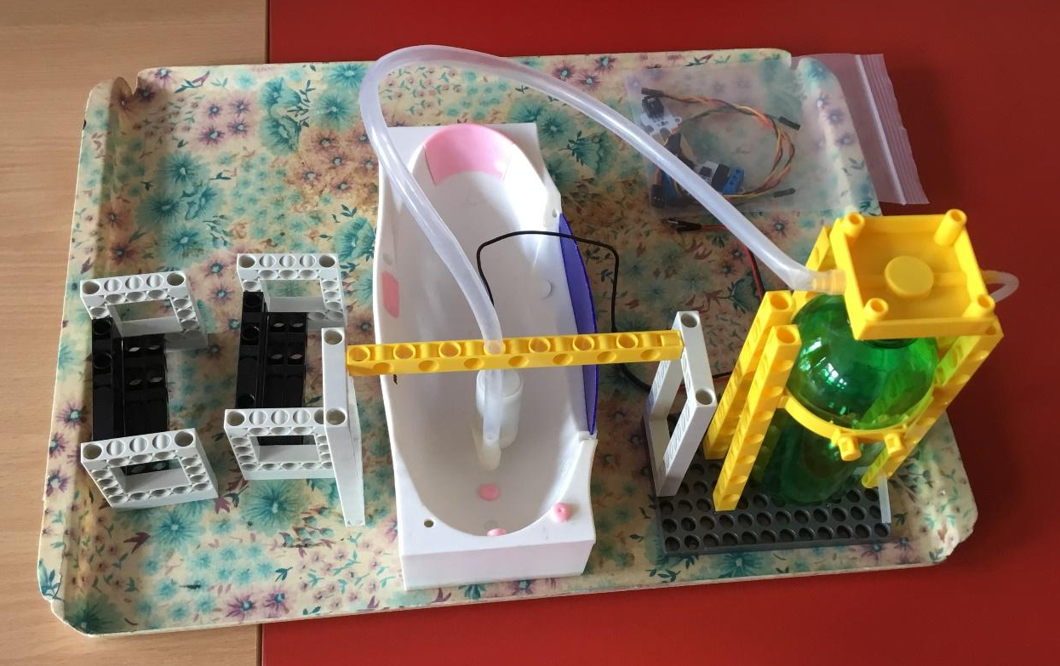

The structure that connects the bathtub to the tank and holds the tank itself is a zen kit itriangl. The bathroom is the only room where the sensor:bit is not screwed to the wall, it is stored in a separate structure (see left).

We put the pump with the level sensor in the bath and connect the sensor:bit. Again, you need to be careful about the pins used. We connect the power cable to the sensor:bit and pull it through the gap between the ceiling and the roof to the roof.
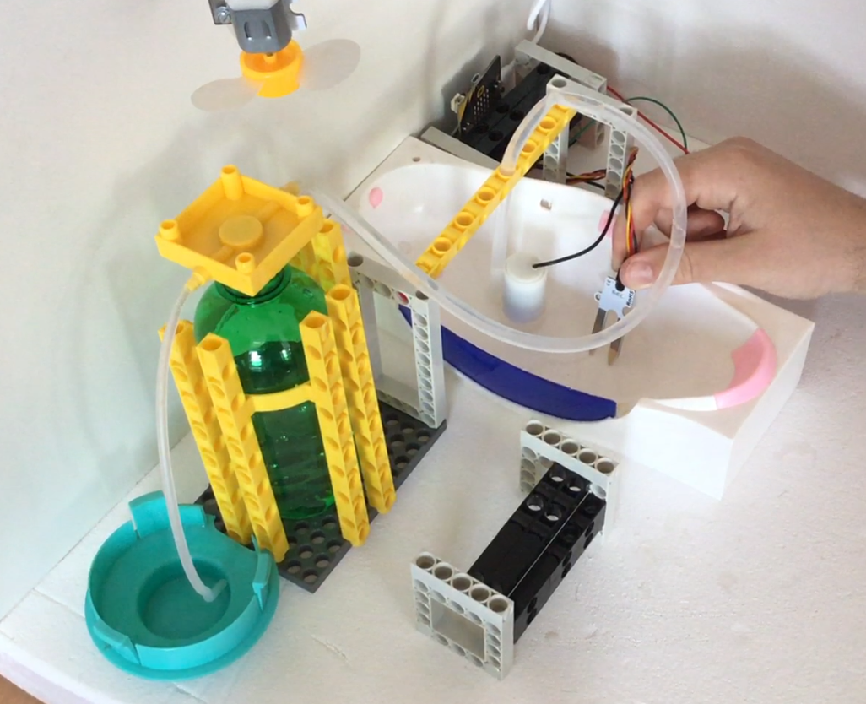

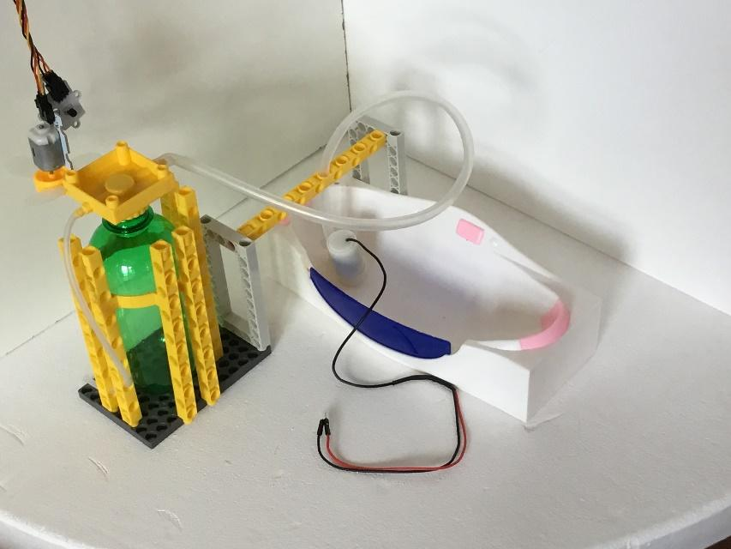

Kitchen
First we prepare the oven. We insert the sensor:bit with the connected LED and power cable into the stove. The glowing LED imitates an oven. Prepare a hole for the power cable in the side of the stove. Attach the noise sensor to the right side with a 3x15 screw. We will lead the power cable to the roof of the house again.
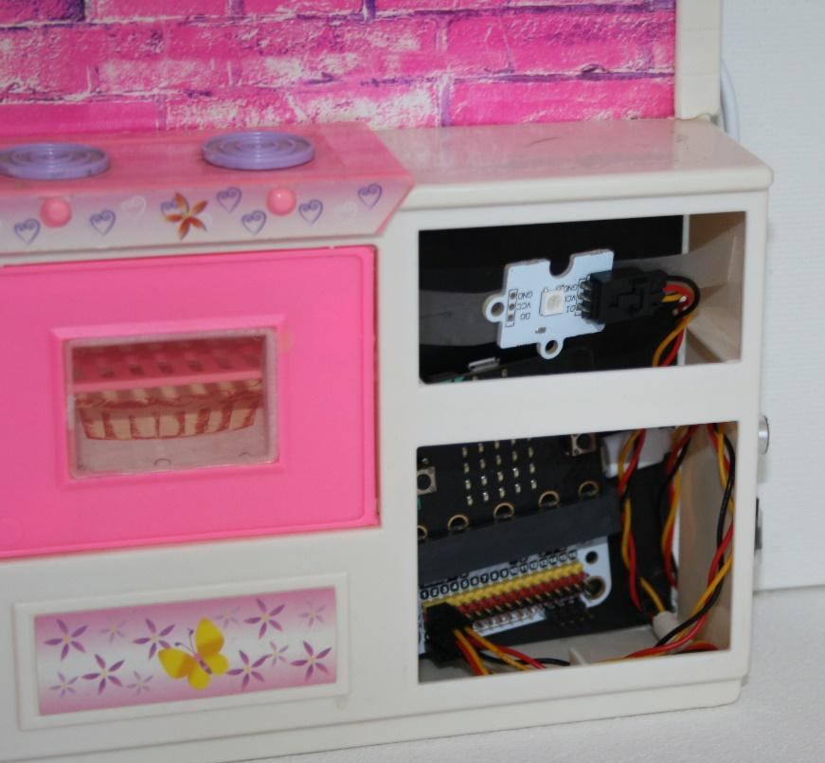
We fix it to the kitchen floor using a part from the Merkur kit and 2 3x30 servo screws, which we connect to the sensor:bit on the wall. We will also connect a noise sensor to the sensor:bit. We will lead the power cable to the roof of the house again.

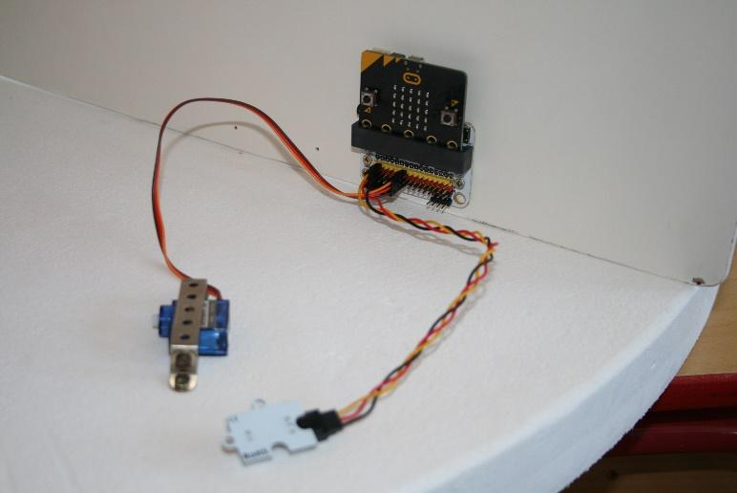
Place the fridge and connect it to the server with a cable. We will create a pull rod from a paper clip or other strong wire. We choose the diameter so that it passes through the hole in the arm of the servo. We set the length according to the location of the servo and the refrigerator used.
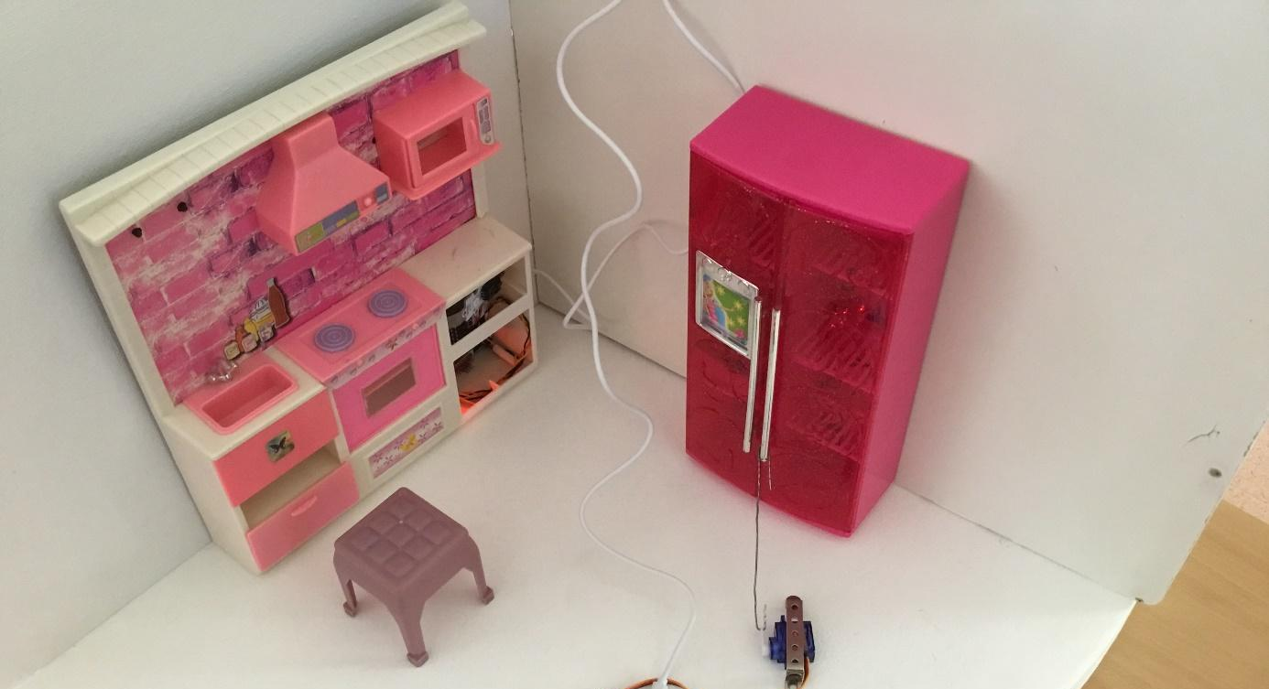
We ran the power cable again and arranged the rest of the furniture.

Bedroom
We will place a stroller and a cradle as the main elements in the bedroom. Again, according to the layout of the furniture, we fix the servos using the parts of the Merkur kit and two screws 3x30.
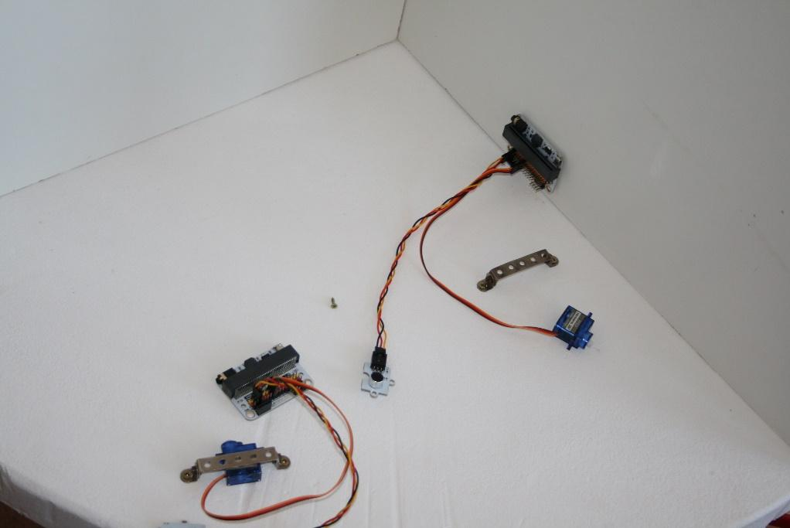.
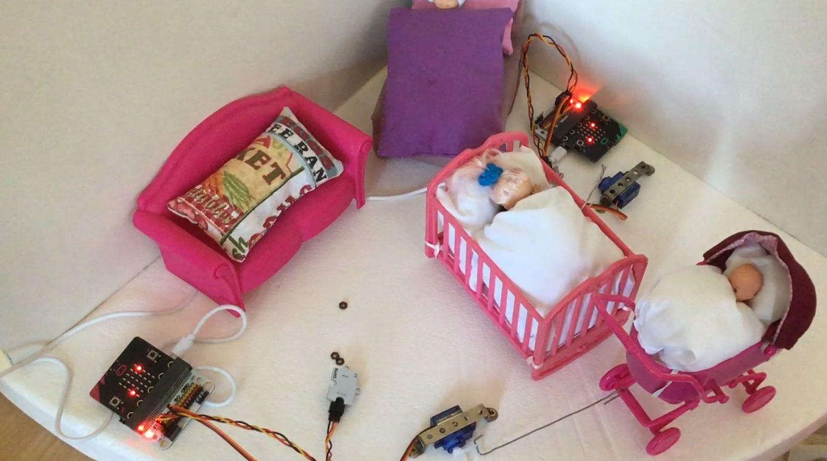
We arrange the furniture and connect the cradle with the stroller using the servo rods. Finally, we run the power cables to the roof.

Living room
Here we have the light and sensor:bit ready on one wall, we will fix the servo to the floor, which we will connect with the door of the cabinet with a cable. We arrange the furniture and run the power cables to the roof again.
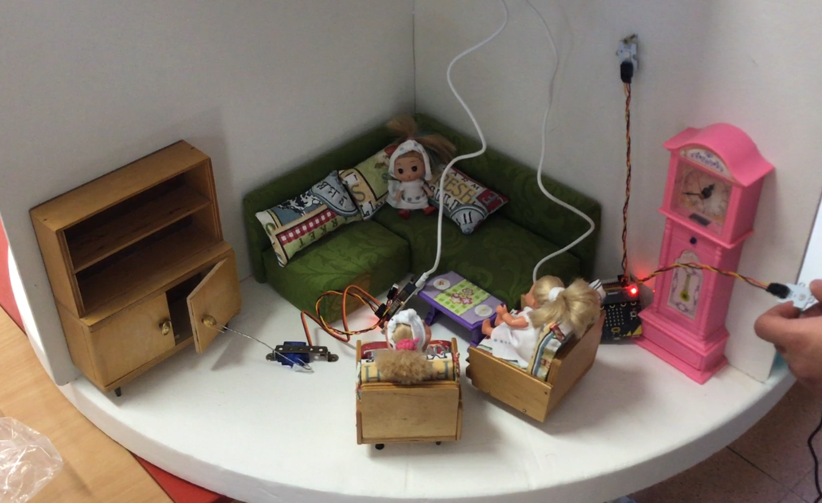

Wind power plant
On the roof of the house is a wind power plant that powers the entire house. It is made of itriangl parts, which are very similar to a LEGO kit. Equipped with an itriangl electric motor and powered by an itriangl power module with two AA cells.
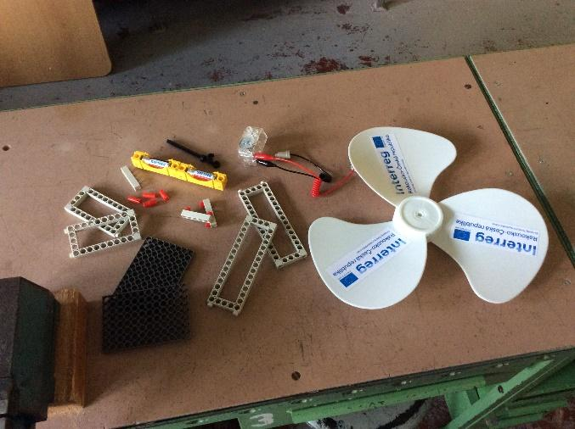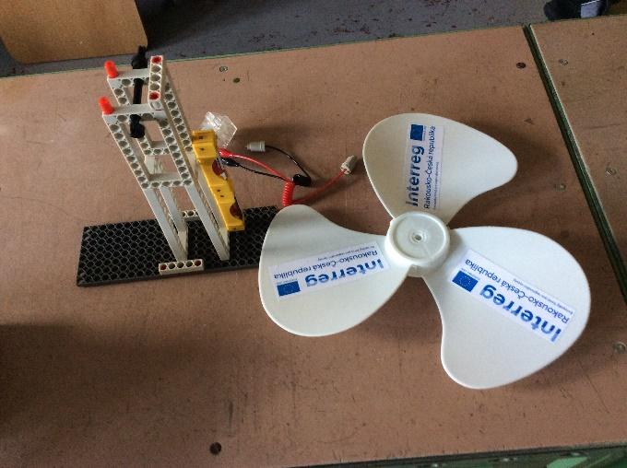
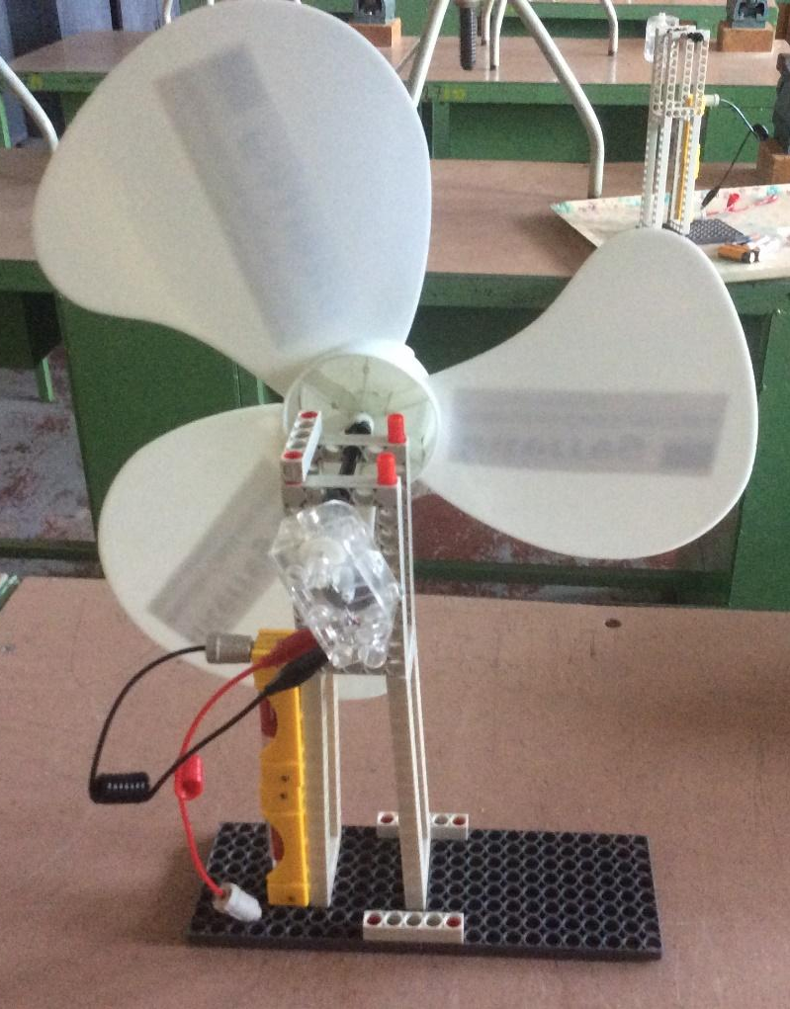

Roof
In addition to the wind power plant, the power supply for the entire house is also located on the roof. To simplify the entire installation, a Belkin B2B139vF USB power supply was used. However, we can replace it with any corresponding USB source, or accumulators or cells from kits based on micro:bit.

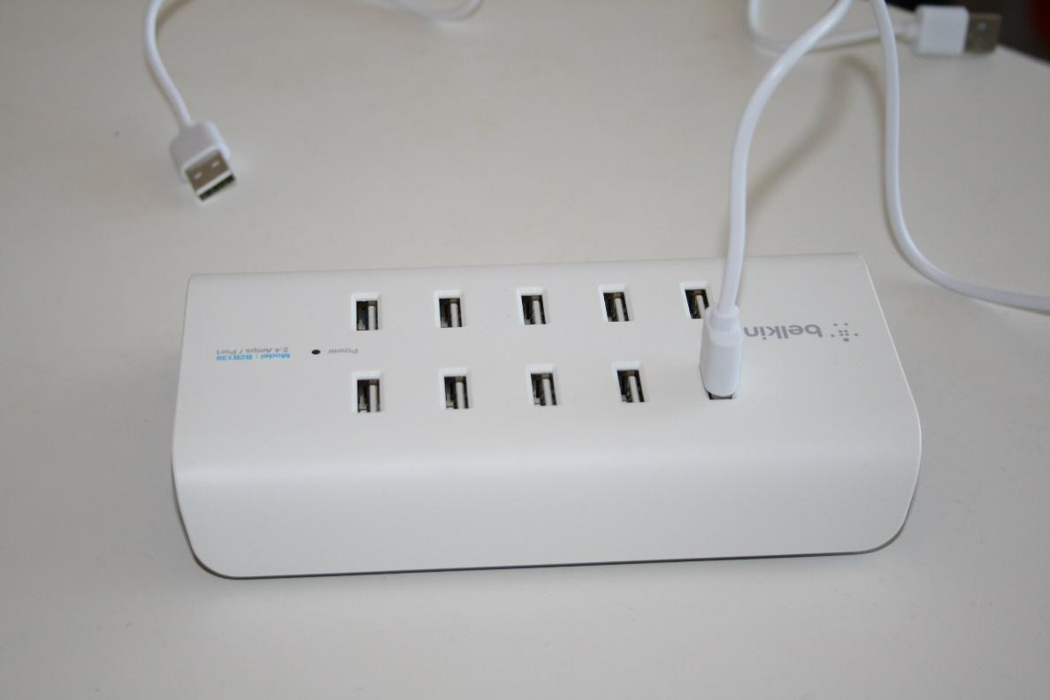

Connections, programs
We will program all micro:bits and connect them to sensors and actuators via sensor:bit. The power is supplied centrally from the USB power supply on the roof of the house. We pass all the cables through the gap between the ceiling and the roof.

Bathroom
Used 1 micro:bit
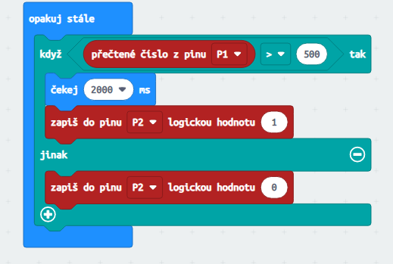

Bedroom
Used 2 pcs micro:bit
Stroller

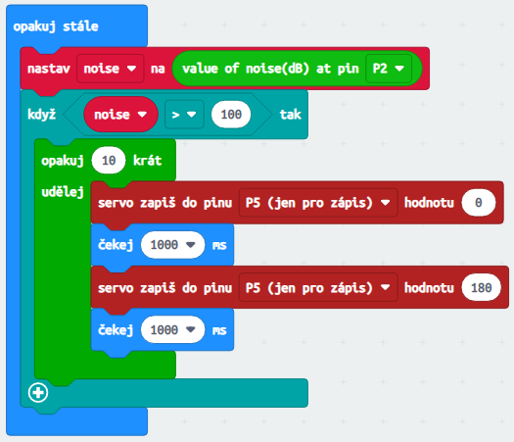

Cradle

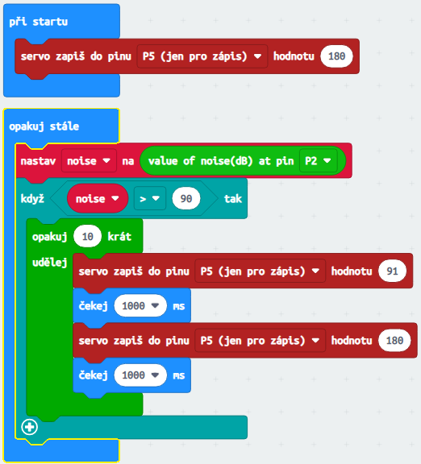

Living room
Used 2 pcs micro:bit
Light

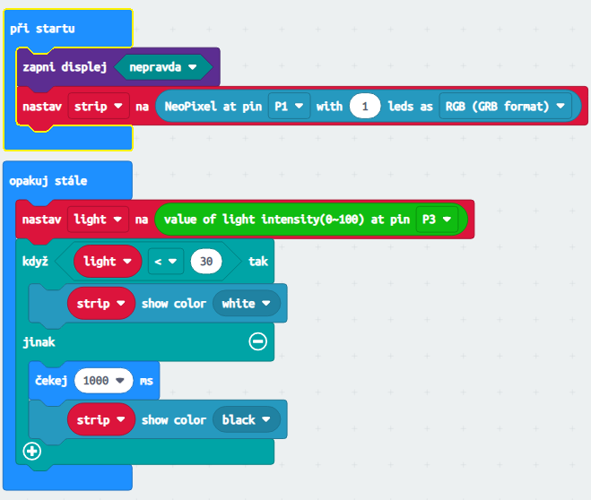

Cabinet
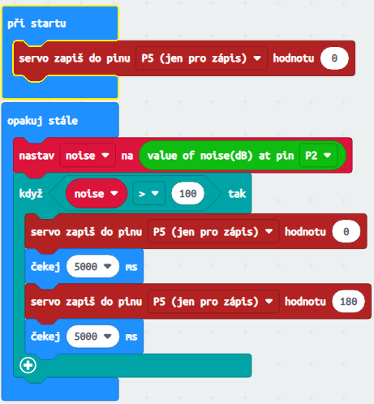

Kitchen
Cooker
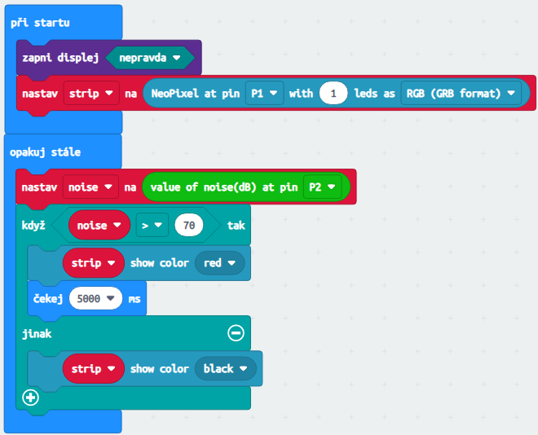

Refrigerator
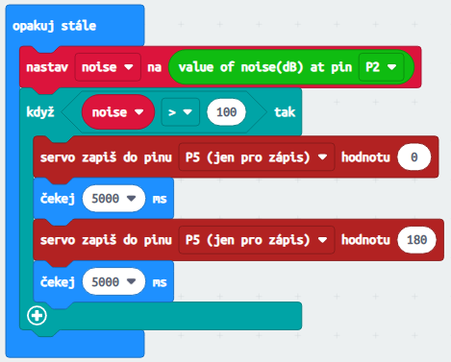

Ventilator
The same program is used for all rooms, it simulates switching on and off during temperature changes.

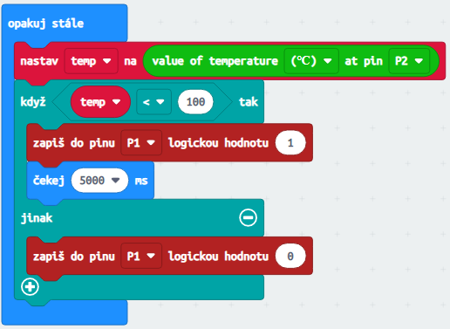

A topic for further work
As a next step in working with the micro:bit and the house, we will try to optimize the number of electronic elements. We will check the possibility of connecting multiple devices to one sensor:bit. The goal is to use only one micro:bit and sensor:bit for each room.
In conclusion, we wish you a lot of fun and cheers.

